In Memoriam: Roman Zlotin
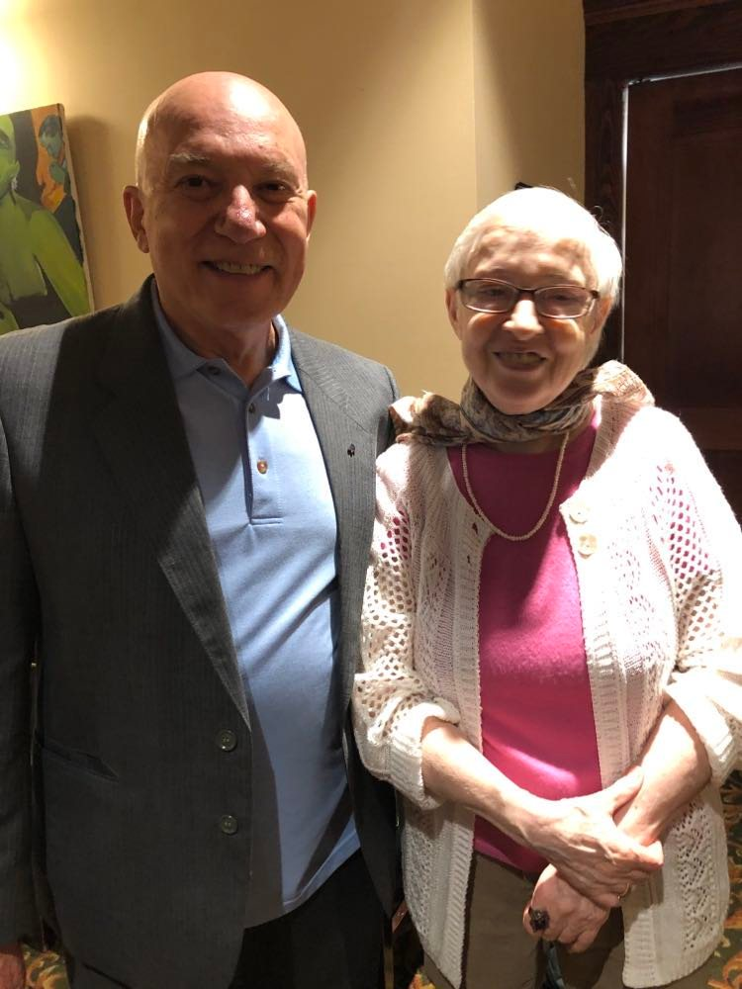
The Department of Geography and the R. F. Byrnes Russian and East European Institute (REEI) are saddened by the death of Lecturer Emeritus Roman Zlotin, our beloved faculty colleague, at his residence on February 26, 2023. The Geography and REEI communities extend heartfelt condolences to Roman’s wife, Sonya, as well as to their son, Alexey, and his family.
Roman was an outstanding and internationally renowned scholar in the field of biogeography, esteemed both by colleagues in his native Russia and at IU Bloomington, where he was additionally known as a versatile and popular instructor over the course of three decades. He remained active in fieldwork throughout his career.
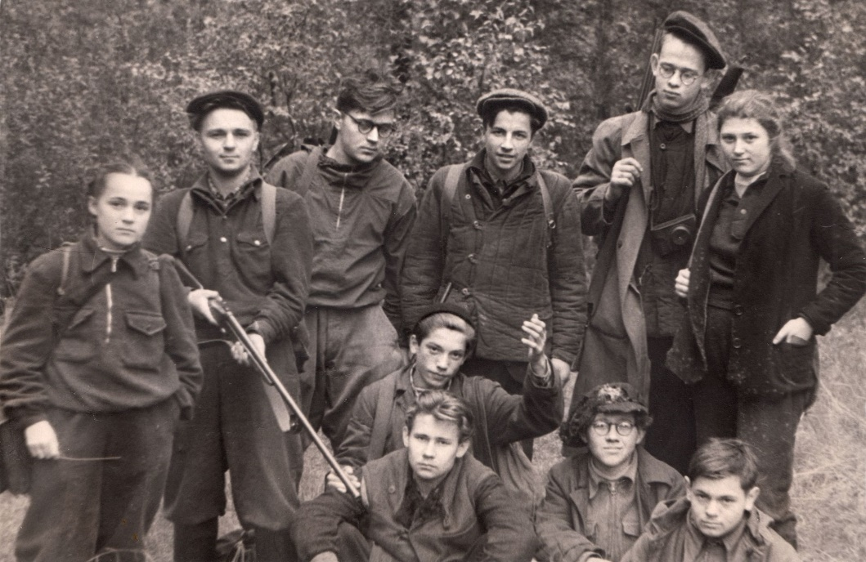
Roman was born in Moscow, USSR on November 22, 1940. As a schoolboy he developed a keen and lifelong fascination with the natural world, actively participating in expeditions to nature preserves and wildlife parks under the auspices of the All-Russian Society for the Protection of Nature. He entered Moscow State University in 1958 as a student in the Faculty of Geography, where he specialized in biogeography until his graduation in 1963. Diploma in hand, he quickly accepted the position of research scientist in the Department of Biogeography at the Institute of Geography of the USSR Academy of Sciences. He soon established himself as a leading specialist on general and regional issues in biogeography and ecology, eventually publishing almost a dozen monographs and more than 100 articles. Roman travelled extensively throughout the USSR as participant and leader of research expeditions to the frozen tundra of Siberia, the mountain vastnesses of the Caucasus and Tien-Shan, and the arid deserts of Central Asia. He also undertook research abroad to such destinations as Norway, where he served as scientific leader of the Russian Ecological Expedition to the remote island of Spitzbergen; Vietnam, as secretary of the Soviet-Vietnamese National Atlas Program that resulted in a comprehensive atlas with over 450 detailed maps of the country; and various islands in the Pacific Ocean as an organizer of expeditions on board the scientific-research vessel Callisto. In 1970 he defended his Candidate of Science dissertation on the “Structure and productivity of high-altitude ecosystems in inner Tien-Shan,” a work that served as the basis for his monograph Life in High Altitudes. He chaired the Department of Biogeography of the Institute of Geography from 1983 to 1994.
Roman Zlotin and his wife Sonya at Roman's retirement party in the spring of 2019 (photo by Veronika Trotter)
The young naturalist: Roman (center, left arm upraised) in the field with fellow participants on an expedition sponsored by the All-Russian Society for the Protection of Nature
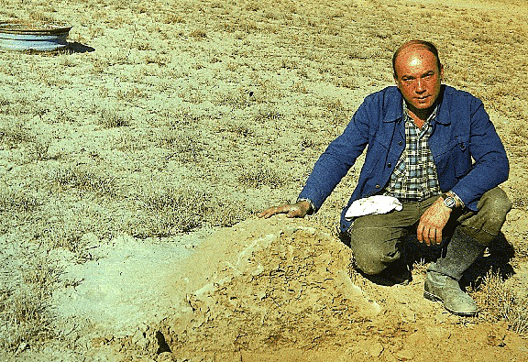
Roman first visited the United States in 1987 when he was invited to deliver a keynote address at the 4th International Wilderness Congress in Denver. In an interview with Matthew Atkins (MA, REEI, 2004) for REEIfication the REEI newsletter, Roman likened his initial impressions of the US to “love at first sight.” His newly conceived affection for the land, cultures, and people of the US and North America as a whole lasted throughout the remainder of his life. Tasked with the establishment of an Earthwatch program in the USSR, he returned to the US in 1989 for program-related training over the course of a 45-day tour that took him from Massachusetts to Hawaii. In 1990, he set foot on the IU Bloomington campus for the first time in order to attend a conference devoted to environmental problems in the Aral Sea. That visit opened the door to an association with IU that ultimately led to multiple appointments over three decades. In Fall 1992, he taught “Environmental Degradation in the Former USSR” for the School of Public and Environmental Affairs (SPEA, now O’Neill). The course opened a new chapter in Roman’s professional life, as he took on the role of instructor for the first time in his academic career, which up till then had been devoted to research exclusively. Notwithstanding his pedagogical inexperience as well as the challenges of both communication in a second language and, as Atkins put it, “immersion in American culture, possibly at its rawest and most unrefined level—that of the college student,” Roman’s classroom debut was a success that led to a series of visiting appointments as both instructor and researcher with SPEA, the Department of Central Eurasian Studies, the Department of Geography, and the Center for the Study of Global Change. Alongside his activity at IU, Roman also formed an association with the University of New Mexico, first as a researcher and subsequently as an adjunct professor in its Department of Biology.
Roman demonstrates the internal structure of a termite mound during an expedition to the grasslands of Kazakhstan in 1987 (photo by Dr. Yasny, Geographical Institute of the USSR Academy of Sciences)
In 2003, Roman was appointed Senior Lecturer in the IU Department of Geography, a position he held until his formal retirement in 2019. Roman regularly taught such Geography courses as “Geography of Russia,” “World Regional Geography,” and “Russia and Its Neighbors.” With the encouragement of REEI, Roman developed a Russian-only version of the latter course for students with advanced proficiency in the language as well as “Environmental Issues in Russia,” another course taught exclusively in Russian. Housed in REEI, these courses proved highly popular among REEI MA students and undergraduate minors as well as students pursuing other programs of study. Even as a retired faculty member, Roman continued to offer a Russian-only course to IU students under the title “Contemporary Issues in Russia” through Spring 2021. At the onset of these courses, Roman prompted each student to submit three topics of individual interest, which he then used to map out the schedule and content of the semester. Each student led at least one discussion after preparation that involved individual consultation with Roman on suitable discussion questions and materials like Russian news articles or other media items to be assigned fellow classmates in advance. “Going to Russian discussion every Friday afternoon for the past two years has been a highlight of my undergraduate experience at IU,” wrote Emma Patterson (BA, SLAV, 2021) for the Spring 2021 issue of REEIfication. “The unique interests of the students guarantee a steady supply of engaging topics, like portrayal of disabilities in Russian media, Broadway and the Arbat, and political opposition in Russia.”
Roman and his students in a Russian-only course as they celebrate the end of Spring Semester 2017 at Yogi’s
Those who knew Roman have been invited to submit reminiscences and testimonials using a Google Doc. Van Holthenreichs, a doctoral student in SLAV who also attended Roman’s Russian-only courses, remembers Roman as “such a massive help in refining my usage of Russian in higher level debates/discussions” and “always just such a happy and nice man who treated all of his students with the utmost kindness and respect.” Upon the news of Roman’s death, Emeritus Professor of Geography Dan Knudsen wrote that “I will greatly miss his wisdom and wit, his recounting of his various escapades while engaged in fieldwork . . ., and our friendly repartee,” adding that he was “so incredibly fortunate to have known Roman and been graced by his loyalty and friendship.” Sarah Phillips, Professor of Anthropology and Director of REEI, expressed enormous gratitude to Roman for many years of teaching as “he guided generations of students through his fondly-remembered ‘Contemporary Issues in Russia’ course, taught completely in Russian, which gave students the opportunity to explore topics in politics, culture, society, and international affairs while polishing their Russian language skills. I attended the course myself several times and will always remember the twinkle in Roman's eye as he got students talking, in Russian, about topics of great interest that they researched and presented to the class. He was a wonderful instructor, colleague, and friend. Every time Roman went to Russia for research, he brought back a memento—often a lovely painting, such as a city or rural landscape—for REEI. These gifts will now live forever at REEI in Roman's memory and as a testament to Roman's generosity of spirit.” Several former Department of Geography students who worked with Roman characterized him as “always so joyful, . . . a kind and gentle soul and a joy to be around.” Many also served as Associate Instructors in his “World Regional Geography” and noted their good fortune for the experience. Roman “was a captivating scholar who provoked [thought] among his students” recalled Amy Savener (PhD, Geography, 2016). Rick Wolfel (PhD, Geography, 2001), now Professor of Geography at West Point, noted that in teaching his classes he still relies on “many of the concepts [Roman] taught me.”
During the final weeks of the current semester, REEI and Geography will arrange an event at which friends and colleagues may share their reminiscences of Roman and honor his memory.
Rest in peace, Roman.

