Continuing Colonialism: How Historical Events Affect Indigenous Communities in the US and Russia Today
The majority of US students do not get a comprehensive, and sometimes even accurate education in indigenous American history and culture. In 2015, researchers from Pennsylvania State University and the University of Missouri found that 87% of Native American‐related content taught in US schools included only a pre‐1900 context. “Indigenous Peoples were largely confined within a pre‐1900 context devoid of any significant voice,” the researchers stated. Once the American West is established, most mention of indigenous communities abruptly stops.

This lesson aims to give students a taste of what a comprehensive unit on modern indigenous history through an international lens might look like. This lesson provides students with an overview of destructive indigenous policies, with a particular focus on indigenous residential schools. It is important that students not only know that a number of US policies were cruel to indigenous communities, and that those policies had lasting effects across generations, but that similar policies existed in the Soviet Union and Canada. It is even more important, however, that students understand that indigenous communities are working to counteract the effects of these policies in their own lives. Indians aren’t dead. In fact, they are part of an active, world‐ wide community.
In order to boost student engagement, this lesson is comprised of student‐led stations. 8 stations were created to accommodate a 1.5 hour block period, but teachers can use fewer or create more using additional resources found on page 7 or from their own toolbox. The stations also allow for a large degree of student choice, as over half of the stations have students choose the material they will analyze.

Unfortunately, this lesson plan does not cover policies which affected Hawaiian natives and was not created by a member of the indigenous community. If you choose to modify this lesson plan, consulting with a local indigenous nation or enrolled member will enrich your lesson, and it will appreciate in value and depth.

This lesson could be taught in connection to a unit on:
- Colonial legacies
- Genocide
- Native American literature or art
- Native American history month (November)
- Indigenous communities around the world
- Indian Boarding Schools
Educators may also contact Indiana University’s Russian and East European Institute (REEI) to arrange for faculty, advanced graduate students, or international students to give a presentation on indigenous peoples in Russia and Eastern Europe, indigenous art of the region,

or another related topic. Please contact Mark Trotter for further information about the Russian and East European Institute or any of its outreach programs at martrott@indiana.edu.
Objectives: By the end of this lesson, students should be able to...
- Compare and contrast US and Soviet policies which affected indigenous communities
- Reflect on the complicated nature of indigenous residential schools
- Name several ways indigenous individuals are addressing the challenges left by harmful policies and acknowledge indigenous resilience
- Assess the consequences of the movement, spread, and changes in the worldwide exchange of pathogens that resulted from exploration and exchanges between peoples in different regions.
- Recognize and analyze how physical and human environments changed as the result of indigenous residential schools and other colonial policies
- Understand that colonialism and imperialism continue to exist and transform today through reading the true stories of indigenous individuals who are trying to combat their effects.
- Compare the formation of the Russian Empire and the United States and identify common and different factors in the countries’ formation
- Comprehend that a Euro‐centric society’s response to its indigenous neighbors led to the creation of a horrific institution in at least two countries
- Identify and compare events in indigenous history in the region that became Indiana and the region that became Siberia regarding contact with Europeans.
- Determine the role the dominant culture has played in the loss of racial/ethnic culture and cultural identity and how it continues to influence it.
- Use technology to write an informative text analyzing historical events Write informative texts, including an analysis of historical events and their consequences today for indigenous communities in the US and Russia

Indiana State Standards and Indicators Addressed:
Social Studies:
Standard 4: Exploration, Conquest, Imperialism and Post‐Colonialism Students examine the physical and human geographic factors associated with the origins, major players and events, and consequences of worldwide exploration, conquest and imperialism.
- GHW.4.2 Use a variety of text (writing, maps, timelines and/or other graphic representations) to show the movement, spread and changes in the worldwide exchange of flora, fauna and pathogens that resulted from transoceanic voyages of exploration and exchanges between peoples in different regions. Assess the consequences of these encounters for the people and environments involved.
- GHW.4.4 Analyze and assess how the physical and human environments (including languages used) of places and regions changed as the result of differing imperialist and colonial policies.
- GHW.4.5 Analyze and assess ways that colonialism and imperialism have persisted and continue to evolve in the contemporary world.

Standard 10: States, Nations and Nation‐States Students analyze and evaluate the physical and human geographic factors that contribute to the formation of states (countries) and the forces that function to either unite and bind a country together or to divide a country.
- GHW.10.2 Analyze the formation of states (countries) in selected regions and identify and appraise the contribution of factors, such as nationalism, in their formation.
Ethnic Studies:
- Standard 1.3: Students evaluate how society’s responses to different social identities lead to access and/or barriers for ethnic and racial groups in relation to various societal institutions, including but not limited to education, healthcare, government, and industry.
- Standard 2.1 Students investigate the origins of various ethnic and racial groups, examining the historical influence of cultural, socio‐political, and socio‐economic contexts on those groups.
- Standard 2.2 Students explain the reasons for various racial/ethnic groups’ presence in the U.S. (indigenous, voluntary, or forcible).
- Standard 2.3 Students compare and contrast how circumstances of ethnic/racial groups affected their treatment and experiences (indigenous, voluntary, forcible) as a response to the dominant culture of the time.
- Standard 2.4 Students examine history and the present to make predictions about what role the dominant culture plays in the loss of racial/ethnic culture and cultural identity.
- Standard 3.1: Students identify and explore current traditions, rites, and norms of an ethnic or racial group(s) and how they have or are changing over time.
WRITING STANDARDS
- 9‐10.LH.5.2/11‐12.LH.5.2: Write informative texts, including analyses of historical events
- 9‐10.LH.6.2: Use technology to produce, publish, and update individual or shared writing products, taking advantage of technology’s capacity to link to other information and to display information flexibly and dynamically.

Overview: After explaining the goals of the lesson and what will be occurring in the classroom, in groups of 4‐5, students participate in an activity for 9 minutes. The activity might involve listening, discussing, reading, drawing, creating a timeline, or watching a music video. After 9 minutes, students move to a new station. Depending on the length of period, students may visit 4‐8 stations. After the final station, the class reconvenes and the class debriefs. The teacher explains the blog post assignment (homework).

Supplies Needed: If you have time constraints, choose which activities out of the 8 would be the most beneficial for your objectives. This will determine which supplies will be needed and how much time students should have at each station. Please be sure to leave time for a debriefing session. The following supplies will be needed for the following stations for 6 groups of 4 students:
- Reading on History of Native & Indigenous Communities in the United States
  - Two print‐outs of the station instructions
  - 2 printed copies of “Native and Indigenous Communities in the United States: Beginnings to 1830” and 2 printed copies of “Native and Indigenous Americans in the United States: Boarding Schools.”
  - 6 pieces of paper (to create timeline)

  - Large manila envelope
  - Optional: Coloring materials for drawing the timeline
- Reading on History of Native & Indigenous Communities in Russia
  - Two print‐outs of the station instructions
  - 2 printed copies of “Native & Indigenous Communities in Siberia: Beginnings to 1917” and 2 printed copies of “Native & Indigenous Communities in Siberia: The Soviet Union and Boarding Schools.”
  - 6 pieces of paper (to create timeline)
  - Large manila envelope
  - Optional: Coloring materials for drawing the timeline
- Chukchi always have been and always will be: Learning how a group of indigenous Russians are challenging the current effects of indigenous boarding schools and other policies
  - Two print‐outs of the station instructions
  - 4 printed copies of “Chukchi always have been and always will be”
- The Conflicting Educations of Sam Schimmel: Learning how an American teenager is challenging the current effects of US indigenous boarding schools and other policies
  - Two print‐outs of the station instructions
  - 4 sets of headphones OR have students bring their own headphones
  - Headphone jack/divider so that 4 people can listen to the same thing
  - A tablet or mp3 player with the radio piece queued up
    - There might be other ways to do this. Please consult with the person in charge of technology at your school
- Primary Source Analysis and Comparison
  - Two print‐outs of the station instructions
  - Two copies of “Excerpt from School Days”
  - Two copies of “Excerpt from The Reindeer People”
- Art and Expression: Poem by Michael Wasson
  - Two print‐outs of the station instructions
  - 4 copies of “Exile” by Michael Wasson
  - 24 blank sheets of paper
  - Coloring materials
  - One large manila envelope
- Analyzing Before and After Photographs of Carlisle Indian School Students
  - Two print‐outs of the station instructions
  - Two copies of the image “FourPuebloChildren_Zuni_before”
    - Write the name of the image on the back and place it face down OR place the image face down and label it
  - Two copies of the image “Tom Tornilo_before”
    - Write the name of the image on the back and place it face down OR place the image face down and label it
  - Two copies of the image “White Buffalo 1881_before”

    - Write the name of the image on the back and place it face down OR place the image face down and label it
  - Two copies of the image “FourPuebloChildren_Zuni_After”
    - Write the name of the image on the back and place it face down OR place the image face down and label it
  - Two copies of the image “Tom Tornilo_after”
    - Write the name of the image on the back and place it face down OR place the image face down and label it
  - Two copies of the image “White Buffalo 1881_After”
    - Write the name of the image on the back and place it face down OR place the image face down and label it
- Music Analysis: Modern Indigenous Artists
  - Two print‐outs of the station instructions
  - One printed copy of “Black Snakes”
  - One printed copy of “Bubble Gum”
  - One printed copy of “Generations”
  - One printed copy of “Please Do Not Touch the Indians”
  - One printed copy of “Spirit in the Sky”
  - 4 tablets or other devices which has internet access and can read QR codes
  - 4 sets of headphones OR have students use their own headphones
    - There might be other ways to do this. Please consult with the person in charge of technology at your school

Educators might also find being able to project a timer helpful to keep students on track.
There is a homework/blog assignment for students to complete. Handouts of the rubric would be helpful to students following the stations portion of the lesson.

Pre‐requisite Knowledge: No previous content knowledge is necessary, but the following information is helpful:
- Basic knowledge of US colonial history. The US government created and broke treaties with numerous indigenous communities, forcing those communities to relocate on multiple occasions.
- Russia is a country and was previously part of the Soviet Union. Before the Soviet Union, there was a Russian Empire.
Students will need to know how to create a timeline. Students will need to be comfortable reading names from languages unknown to them (Dakota, Chukchi, etc.) in small groups.

Students will learn the terms below through their stations. If you would like to prepare students before the class period, you might have them look up their definitions before the lesson.

Deracination | Glasnost |Husbandry | Indian Removal Act of 1830 | Initiative | Intergenerational Trauma | Sedentism | Subsistence activities
Introduce the Stations: At the very beginning of your class period, tell students your objective for the lesson and why you chose this lesson. Explain how this class is going to fit into the unit. For example, “As our class is US history, and today begins Native American history month, I’d like our class today to serve as a kick‐off to a unit on indigenous US history. My goal for today’s lesson is that you learn about residential boarding schools, a policy which affected indigenous communities not only in the US, but also the Soviet Union, and understand that such policies can have lasting effects, generations later.”

Tell your students that your class today will be using stations. If you choose, you may walk to each station and tell the students what to expect there, if they will need technology, etc.
Explain that stations are meant to be interactive and collaborative. Students can learn just as much, if not at times more, from one another as from the teacher. However, determine the level of noise you will accept and tell your students that you will be reinforcing that level.
Students can’t collaborate if they can’t hear one another.

Just like all student‐centered lessons, students need to be accountable for their own learning. In order to do that, each student has a handout packet. At several stations, students are asked to record their findings from the station into the packet. At other stations, students are asked to turn in their work at the station. There is one station where students simply discuss afterward as the piece they listen to is 8 minutes long (The Conflicting Educations of Sam Schimmel). Tell students that they will be turning in their packet with their homework assignment, so they may use the space for notes to help with the homework.

However you see fit, split your students into groups of 4‐5. Tell each group at which station they will begin, and tell your students the flow of the stations. Up at the front of the classroom, project a timer for 9 minutes on your screen. Then you may begin!
Station Facilitation: Walk around the room, guiding students throughout the process. Feel free to join students in their discussions, asking hard‐ball questions. Your interactions will help students stay on task. Be time keeper and make sure you leave enough time to debrief with your students.

Wrap‐up: When the timer goes off for the final station, gather your students back together for a debriefing session. Questions you might ask depend on how this lesson fits into the larger unit, but some sample questions might be:
- What conclusions can you draw from participating in these stations?
- What information was supported by other stations?
- Why do you think it was important that you learned not only about indigenous history and culture in the US, but also in Russia?
- Which station was the most informative/challenging/enjoyable/interesting for you and why?

- What questions do you now have after having participated in the lesson?
In the final minutes of the debriefing session. Introduce their homework: a blog post. The platform you’d like students to use is up to you. Students can create a Google Document, post on a discussion on Canvas, simply write up a Word document, etc. A rubric has been created for your convenience. Students are to answer in their blog post:

How do events which occurred generations ago affect indigenous communities in Russia and the US today? Compare and contrast various US and Russian policies, their effects, and ways indigenous communities in those countries are overcoming those challenges. Use information learned in class and find additional materials to support your claims.
Students who address all parts of the prompt, use excellent organization of ideas throughout their post, use sources both from class and outside it to support their argument, cite their sources, and use correct grammar will earn full points. Students may be as formal or informal as they like with their writing as long as they follow the guidelines. Students can insert video clips, videos, or links to give their readers more context. Students should not assume their reader was in class today and knows what students will mean when they say, “The station where…” Students should also include a short list of references at the bottom of their blog post, like a bibliographic entry. Please add or remove assignment criteria to better fit your goals for this lesson plan.

Additional resources:
- American Indian Removal: What does it Mean to Remove a People? module from Native Knowledge 350°, an initiative of the Smithsonian’s National Museum of the American Indian. This module focuses on the Muscogee and Cherokee Nations and their removal, however it does include information about other nations as well. The module includes handouts, videos, maps, and other resources.
- Tales of the Mighty Code Talkers graphic novel by Arigon Starr (author, editor, illustrator), Roy Boney Jr. (illustrator), Theo Tso (illustrator), Kristina Bad Hand (illustrator), Jonathan Nelson (illustrator) and Renee Nejo (illustrator). The graphic novel shares the true stories of Native American Code Talkers who served their country between World War I and the Korean War. There is also a lesson plan on code talkers for teachers at the end of the book.
- Dawnland hour‐long documentary from PBS’ Independent Lens. The documentary displays the consequences of assimilation policies that were compulsory for Wabanaki children and families in the state of Maine.
- A short article from the Honolulu Star Advertiser on the manifestations of cultural trauma can serve as a talking piece, showing how intergenerational trauma exists among many indigenous groups.
- 15 Lesson plans from the Carlisle Indian School Digital Resource Center
- Podcast Stuff You Missed in History Class offers quite a few episodes on Native American history. Podcasts are about a half hour long.

- Native America: A History is a textbook published by Wiley‐Blackwell in 2017. Educators can use sections from the textbook and its corresponding web manual.
- Blog post on facilitating successful learning stations in the secondary classroom. There is another blog post by the same author on creating learning stations if you chose to add your own to this lesson plan.
Appendixes: The Stations
Email reei@indiana.edu or Mark Trotter (martrott@indiana.edu) for the original and clean copies of Station Instructions, which will not have the appendix label.

- Reading on History of Native & Indigenous Communities in the United States (A1, A2, A3)
- Reading on History of Native & Indigenous Communities in Russia (B1, B2, B3)
- Chukchi always have been and always will be: Learning how a group of indigenous Russians are challenging the current effects of indigenous boarding schools and other policies (C1, C2)
- The Conflicting Educations of Sam Schimmel: Learning how an American teenager is challenging the current effects of US indigenous boarding schools and other policies (D)
  - Link to news story: https://www.npr.org/sections/goatsandsoda/2018/05/30/610384132/the‐ conflicting‐educations‐of‐sam‐schimmel
- Primary Source Analysis and Comparison (E1, E2, E3)
- Art and Expression: Poem by Michael Wasson (F1, F2)
- Analyzing Before and After Photographs of Carlisle Indian School Students (G1, G2, G3, G4, G5, G6, G7, G8)
- Music Analysis: Modern Indigenous Artists (H1, H2, H3, H4, H5, H6)
  - https://www.youtube.com/watch?v=eP2fF5f7gjA Arigon Starr (country)‐ No video
  - https://www.youtube.com/watch?v=Z7U5GCrMWOo Pamyua (pop)
  - https://www.youtube.com/watch?v=3EmUmbhDRiY KEiiNO (pop)
  - https://www.youtube.com/watch?time_continue=77&v=QdeHUrL1FEM&featur e=emb_logo Prolific the Rapper (rap)
  - https://www.youtube.com/watch?v=uTu5M4uiZ94&list=OLAK5uy_khs0ytwXB5k 0wmejrJyfmYAURug0iSPP4&index=2&t=0s Nadjiwan (rock)
- Handouts (J)
- Homework Rubric (K)

Appendix A1

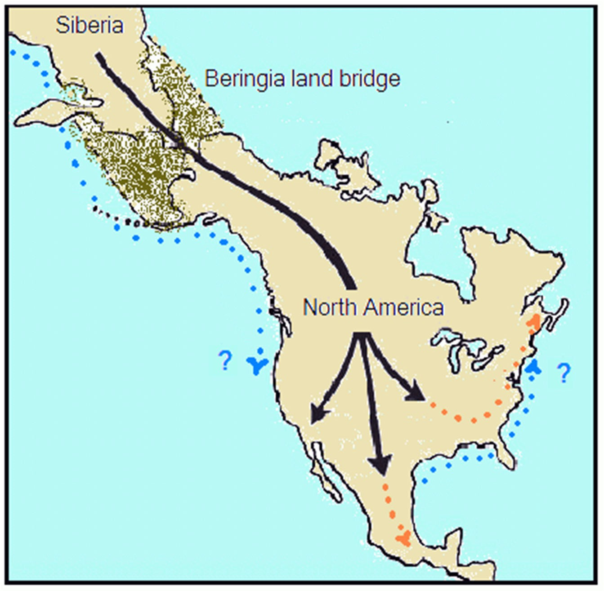
Scientists today believe indigenous Americans migrated from the area known today as Siberia through the Bering Strait 15,000‐30,000 years ago. At that time, there was land and ice between the Chukot peninsula and Alaska, making travel possible. Image published by Arline McKenzie, https://slideplayer.com/slide/10066685/

Native and Indigenous Communities in the United States: Beginnings to 1830
At the end of the Ice Age, humans first came to North America across a land bridge that existed between the lands known today as Chukotka, Russia and Alaska, United States.
This land bridge was called the Beringia land bridge, but today the Bering Strait¹ is in its place.
Scientists believe these people came between 30,000 and 15,000 years ago. As they migrated from Siberia², they moved south into present day Canada, United States, Mexico, and even further south into Central and South America.
Eventually, some of these early inhabitants settled in the area we know as the continental United States. They tended to live and

travel along rivers and work with copper. Some of the largest indigenous groups in the area known today as Indiana were Delaware, Miami, Shawnee, and Potawatomie communities.
French traders were some of the first Europeans to come to the area we know today as Indiana. They arrived in the 1670s hoping to trade for furs. The indigenous community traded their furs with the European traders in exchange for metal wares, cloth, and guns. The indigenous community also came into contact with the Europeans’ germs, causing diseases to spread and many to die. The relationship between the French and indigenous populations was peaceful, though. This might be because there weren’t many French in the area, and they had to learn to negotiate and be respectful in order to trade successfully.
As Europeans continued to migrant to North America, however, this peace began to wane. British and French colonists fought for control of areas further than the British 13 colonies. They

¹ A strait is a narrow waterway connecting the Arctic and Pacific Oceans
² Siberia is the part of Russia which sits in Asia. The area of Siberia is a little over 5 million square miles (the US is only 3.8 million square miles).

fought with various indigenous communities as allies, eventually fighting battles all over the world with the help of other allies like Portugal or Russia. In 1763, the fighting stopped, ending the French and Indian War and the Seven Years War. Britain had gained considerable power in North America. However, due to the expense of the war, the British government raised taxes on all citizens, including the colonists, to offset the costs. This hike in taxes led to colonists’ unrest and the American Revolution.
Following the French and Indian War, King George III declared land west of the Appalachian Mountains land for indigenous communities to live, meaning land east of the mountains was for European settlers. This, however, was only the beginning of the push of indigenous communities further and further from European settlements. This led to a series of wars: the Northwest Indian War (1785‐1795), the War of 1812 (1811‐1814), and other wars fought west of the Mississippi River. The Indian Removal Act of 1830 forced indigenous communities to move west of the Mississippi River, but as the law was redefined over time, so were the spaces indigenous communities could live.
- What are some key events of indigenous American history in the early US?
- Why do you think life between Europeans and indigenous Americans was less peaceful as more Europeans came?

Appendix A2
Native and Indigenous Americans in the United States: Boarding Schools
Boarding schools for indigenous children slowly began to open around North America. Although there were some boarding schools for indigenous children as early as 1634, more and more began to open in the late 19th century. The goal of these schools was to assimilate indigenous children into Euro‐American culture and give them an education in Euro‐American subjects.
Children lived at the boarding schools and were apart from their families. The first schools were opened by missionaries. In 1879, Carlisle Indian Industrial School was founded. This boarding school served as a model for other boarding schools across the country. In 1891, the US government issued a law that all indigenous children must attend schools which were designed and administered by the Euro‐American population. This law meant federal officers could take children from their home and force them to attend boarding school.
While at these schools, children were forced to change their outward appearance (haircut, clothes, etc.), as well as behavior. Children were not allowed to speak their native languages or practice their spiritual beliefs. Later investigations found that children at these schools were not treated well and suffered various forms of abuse. After hearing the stories of children who grew up at these schools, the US government signed the Indian Child Welfare Act into law in 1978, giving Native American parents the legal right to choose where their children were placed in school.
- What do you think life was like for children at the Indian boarding schools?
- Why do you think it took about 90 years for the US government to let indigenous parents choose where their children went to school?

Appendix A3
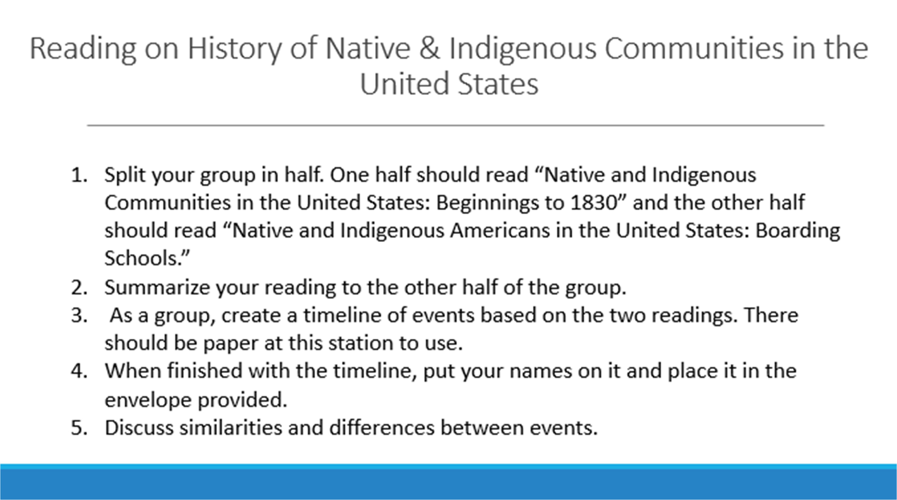

12

Appendix B1

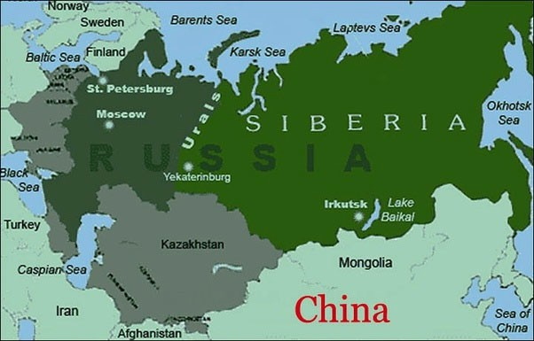
Native & Indigenous Communities in Siberia:

The bright green part of the map is the part of Russia located in Asia, east of the Ural Mountains. This part of Russia is called Siberia.
Beginnings to 1917
Like the United States, Russia’s population is incredibly diverse. People practice a variety of religions including Christianity, Islam, and Buddhism. In absolute numbers, Russia takes in the largest number of immigrants of any country after the United States and Germany. More than 120 languages are spoken in Russia, and many of these languages are indigenous languages. While there are indigenous people all over Russia, the majority of Russia’s indigenous communities live in Siberia, the part of Russia that sits in Asia.
Many indigenous groups in Siberia were nomads. In the 13th century, the Mongol Empire conquered part of Siberia, and indigenous communities under Mongolian rule had to pay the Mongols a kind of tax called a tribute. These tributes could be furs, goods, or services. The Mongol Empire stretched all the way to the European part of Russia. By the beginning of the 15th century, the empire began to lose power and other groups took over various territories. One of those groups was the Muscovy, which would eventually become the Tsardom of Muscovy, and then the Russian Empire.
In the 16th and 17th centuries, forces from the Tsardom of Muscovy fought other groups which had conquered land from the Mongols in Siberia. The Tsardom wanted land and the people’s tributes. These fights became known as the Russian conquest of Siberia. By 1639, ethnic Russians reached the Pacific Ocean and by 1640, the Tsardom included all of northern Asia, or Siberia. The conquest did not end in 1640, however. While some communities didn’t mind paying tribute to the Tsardom, there were many battles between ethnic Russians and indigenous communities who did not want to pay tribute. Many were killed in battles or by European germs. In some communities, the majority of the community died.
In the 17th and 18th centuries, the Europeans who lived in Siberia were hunters and those looking for a new life outside of European Russia. Some of those people were Old Believers. Like the Puritans and other first European settlers in North America, the Old Believers lived in Siberia so that they could practice their religion in peace. Even as time passed, there were few Europeans in Siberia, and indigenous communities and European newcomers lived in relative harmony following the conquest.
- What are some key events in indigenous history of Russia?
- Why do you think the Tsardom of Moscovy wanted to take Siberian land?

Appendix B2

Native & Indigenous Communities in Siberia: The Soviet Union and Boarding Schools
In 1917, there was a revolution in the Russian Empire. The USSR (Union of Soviet Socialist Republics), or the Soviet Union, took its place. The Soviet Union was a country from 1922‐1991.
In the early years of the Soviet Union, the government adopted policies designed to preserve indigenous traditions. Schools were opened for indigenous children in their traditional territories and the schedule reflected their seasonal activities. For example, some indigenous groups migrated to a warmer area in the winter. That meant children who were in the area attended school in the warmer months, and in the colder months, the school was closed. The government also created a written standardized version of several languages so that children could learn to read and write in their own language. However, indigenous communities were not invited to take part in these initiatives, and thus some initiatives were more effective than others.

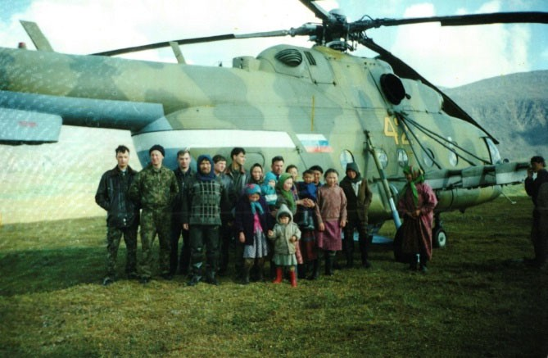
Nenets (an indigenous group of Siberia) children before they head on the helicopter to school. These children live with their families in the summer and live at a boarding school 9 months of the year. The helicopter takes them to and from school. Photograph by Ikuru Kuwajima , https://flashbak.com/tundra‐kids‐nenet‐children‐inside‐ russias‐indigenous‐boarding‐school‐370914/
When a new leader, Joseph Stalin, came to power, initiatives to empower indigenous communities were stopped. Following World War II, nomadic indigenous groups were forced to settle into one place. This practice is called involuntary sedentism. From age 2, indigenous children had to attend boarding schools where they could not speak their indigenous language. Students could be taken from their families if their parents refused to send them to boarding school. Students learned Russian language and Russian culture far away from their families and were not able to talk with them during the school year.
By the mid‐1980s, children were allowed to return to their home communities thanks to the new openness or glasnost policies of the USSR. For the first time, people

were able to openly talk about the problems of boarding schools and of children not being able to live with their families. Smaller schools in settlements and towns began to be built and some nomadic schools reopened. Boarding schools remained open, but families could now choose whether or not they wanted to study at them.
- What do you think life was like for children at the Russian indigenous boarding schools?
- Why do you think it took about 40 years for the Soviet government to let indigenous parents choose where their children went to school?

Appendix B3
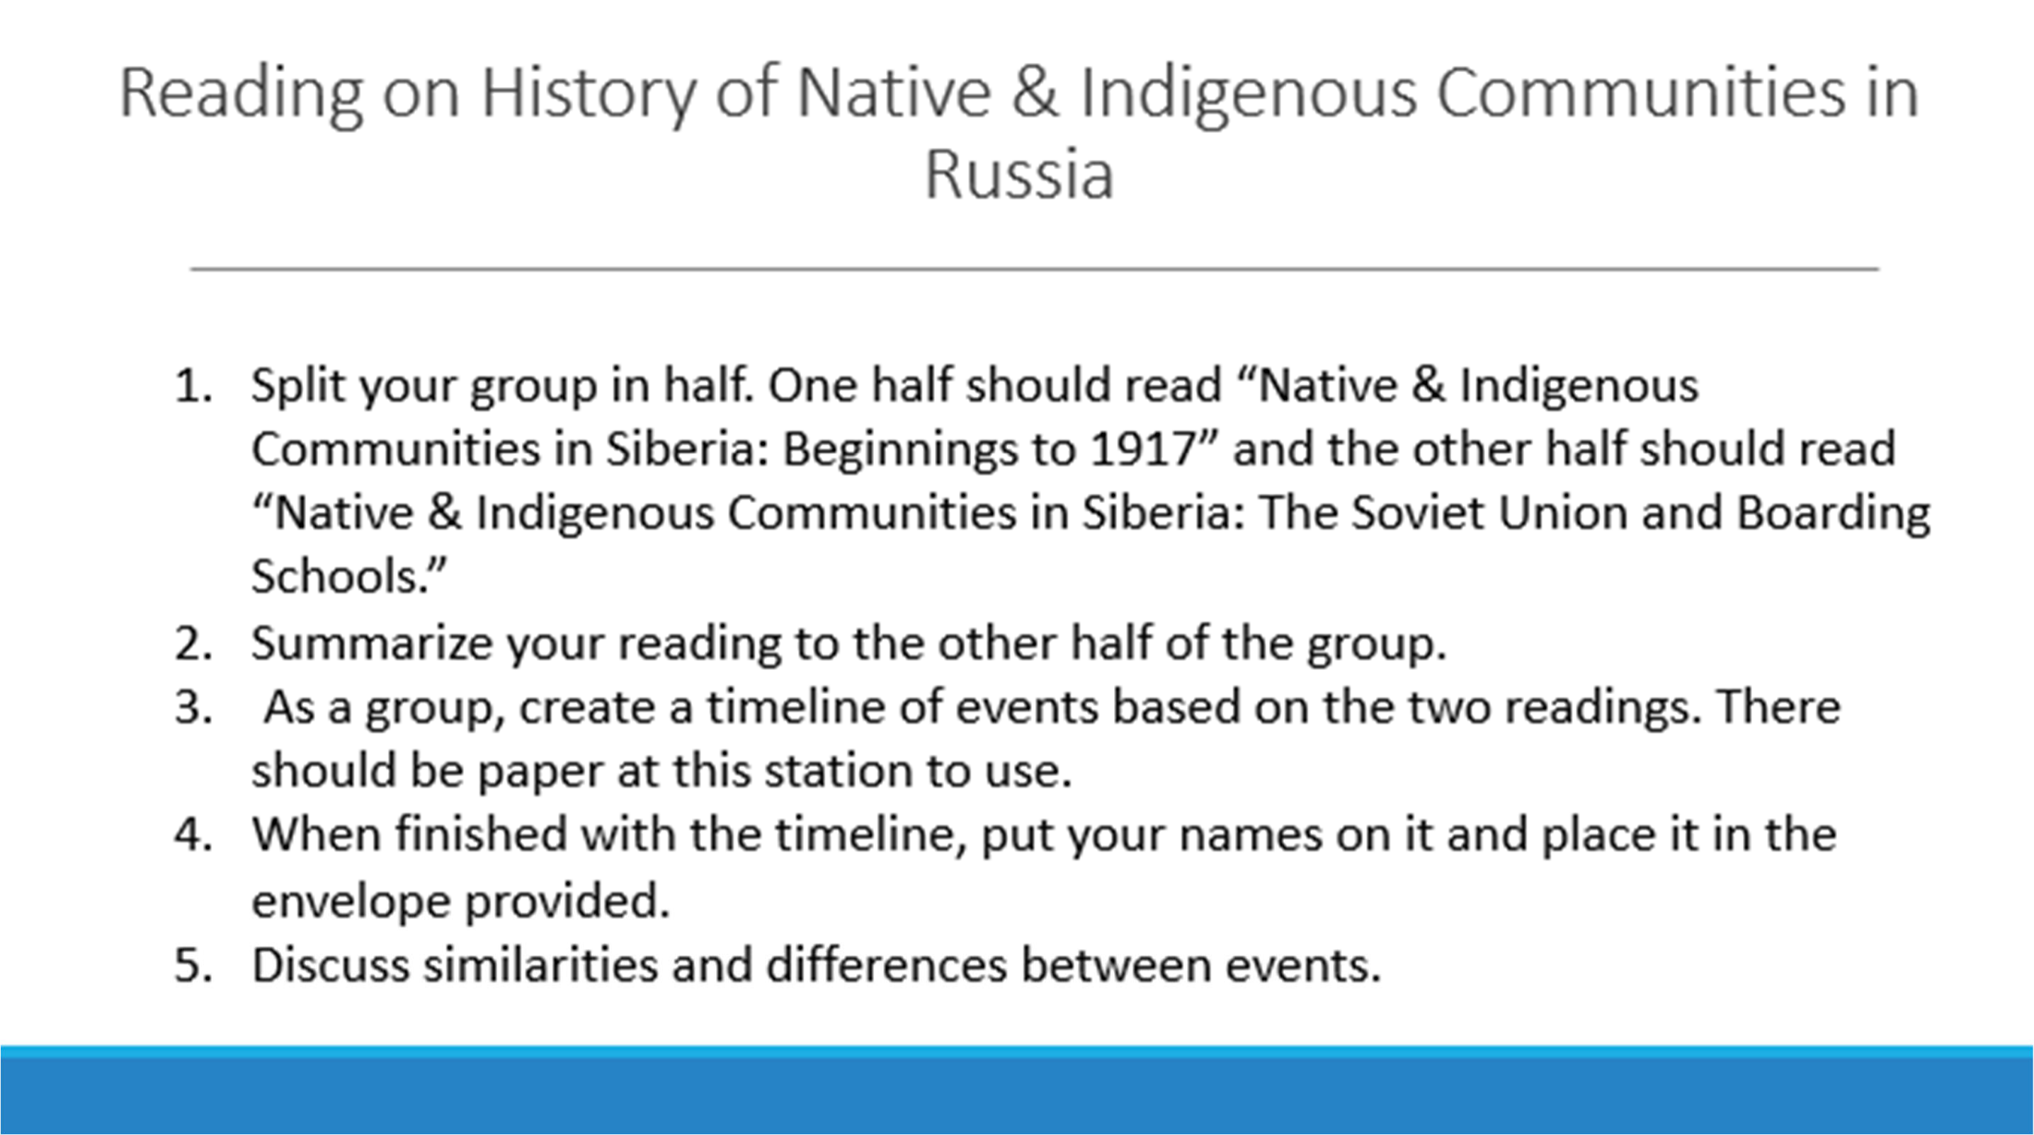

15

Appendix C1
“Chukchi always have been and always will be.” How an indigenous people are saving their heritage in the era of globalization.
9 August 2018, 03:28 | Article in Russian at: https://tass.ru/v‐strane/5437051. Written by Sergei Sysoikin with photographs by Yuri Smitiuk. Translated and adapted by Clare Angeroth Franks.
Adapting to the fast changes of the modern world is a difficult feat. One of the biggest challenges facing indigenous communities is indigenous language loss due to globalization. On International Day of the World's Indigenous Peoples (August 9), TASS tells how an ancient people of the upper North lives and takes on such challenges today.

Chukot and Russian
Mikhail Zelenskii (Chukot last name‐ Gyrgol’tagin) is the son of nomadic teachers and is a former head of Chukotka Autonomous Okrug, or Chukotka. This peninsula is home to the largest part of the Chukot population, about 18,000 people. Zelenskii is a native Chukot speaker as he was born, grew up, and lived in the region his whole life.
Zelenskii has lived through one of the most difficult periods in history. At the end of the Perestroika era³, life in Chukotka was unbearably harsh. At that time, reindeer husbandry⁴ was declining and the fishing industry was on the edge of collapse, both of which constituted major sources of income for the region. Children were forced to learn in internaty, or boarding schools, meaning they were separated from their families.
“Children were torn from their parents, losing their linguistic heritage. Today in Chukotka, there have been several efforts to bring back and remember the language, but there aren’t any major means to accomplish this. Chukot is a very complex language and you have to practice it constantly,” says Zelenskii.

A Handbook for Language and Traditional Subsistence Activities⁵
Thanks to help from the local government and residents, indigenous language loss in Chukotka is beginning to reverse. A team of local residents are working on a textbook of the Chukot language, and Zelenskii is the leader of this project. The team will create video clips to use as supplemental materials for Chukot language classes.

³ Perestroika (literally: restructuring) was a Soviet political and economic movement of the 1980s and early 90s, which led to the Soviet Union’s transition from a communist to capitalist state.
⁴ Husbandry is the care, cultivation, and breeding of crops and animals.
⁵ Subsistence activities are the traditional collection, harvest, or use of natural resources for personal or familial needs or use, and not for commercial purposes. Examples of such activities include growing and gathering food; fishing; hunting; sewing; etc.

“We’ve already planned a topic on baidars⁶, fishing, reindeer husbandry, and dog breeding. They will all be part of the lessons, vocabulary, and phrases, but there will be a translation for those who don’t engage in such activities,” says the former official.
The community has also shown an interest in preserving the language through tradition. For example, in the fishing village of Lorino in Chukotka, villagers try to have all official discussions about hunting be exclusively in the native language in order to keep the language alive.
“If the Jewish community can restore their language, why can’t Chukchi do the same?” Zelenskii asked rhetorically. Zelenskii added that he sees a need for Chukot language classes to be mandatory in schools and not just optional, as they are now.

Reconnecting with their Roots
Like preserving language, following tradition can be especially important for the survival of a group’s identity. Zelenskii states that holidays in particular can connect a community. He gives an example of the holiday “Erakor,” which is celebrated in the tundra. Part of the holiday program involves reindeer races where participants not only compete on sleds, but also on their animals. The event is accompanied by a market and food tents, with spectators wearing traditional costumes made of fur.
While celebrating traditional holidays can give community members a sense of their Chukot identity, there have also been several other projects which have also prompted Chuchki to get in touch with their roots. The project “My Genealogical Tree,” has been particularly successful. Communities host competitions for people looking for ways they can connect with the history of their people more deeply. By researching their family tree, people can feel a stronger bond with previous generations. A recent competition winner in the youth category, Irina Rychim, created a family tree which took up 76 pages with information about her relatives and their photographs.
In the tundra of Meynypilgyno, a local resident named Anatolii Cheivytegin followed in the footsteps of his ancestors and opened the first reindeer husbandry farm in the area. The success of his business left several other residents eager to follow his business model and look for similar opportunities. This year Cheivytegin decided to team up with them and won a grant for 3 million rubles ($47,000) from the regional government and a local non‐profit. With these means, he bought equipment and more than 600 reindeer. The farm will fill the need for skins and meat for part of Chukotka’s south. During Soviet times, Chukchi did not fully own their reindeer, as all reindeer were owned by the government. This is still the case today, but as Cheivytegin’s efforts prove, locals are trying to bring back ancient traditions in modern ways. And as Zelenskii asserts, the examples of Cheivytegin’s farm and “My Genealogical Tree” are only the beginning.

⁶ A baidar is a rowing boat for traditional fishing and transportation

“We Won’t Die Out”
Mikhail Zelenskii is sure that Chukchi have a future.
“Chukchi have always been and always will be,” he states. “The potential for us to grow is there. The main thing is: where there’s a language, there’s a people. In Alaska, I saw on a sign written, ‘We won’t die out,’ and Chukchi won’t die out.”

Appendix C2

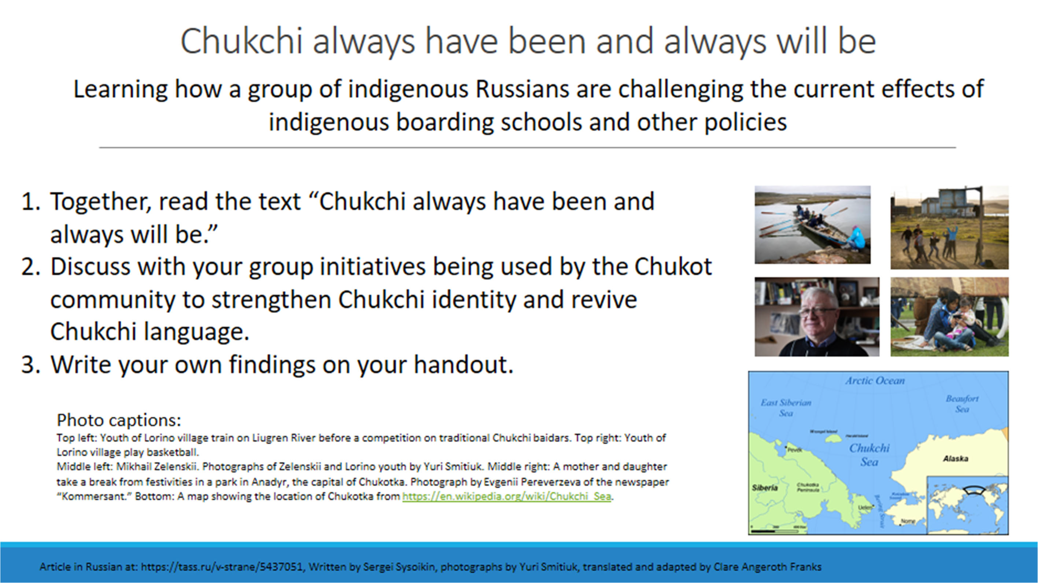

Appendix D
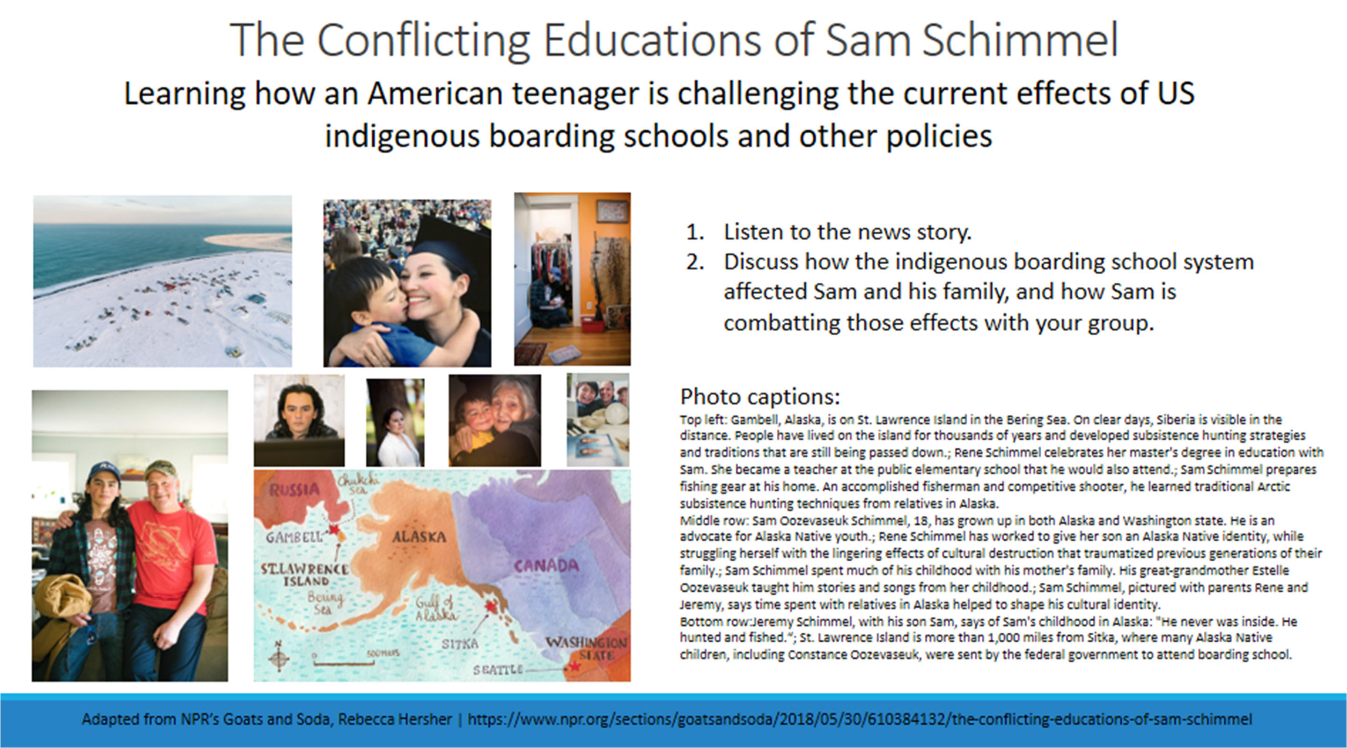

Appendix E1

Zitkála‐Šá was a Yankton Dakota Sioux writer, translator, musician, educator, and political activist. She is also known as Gertrude Simmons Bonnin. Zitkála‐Šá was born in 1876 on the Yankton Indian Reservation in South Dakota. She lived with her mother and brother on the reservation until 1884. That year, she and several other Yankton children began to attend to Indiana Manual Labor Institute in Wabash, Indiana. In 1887 she left the school and returned to the Yankton Reservation to live with her family. Several of her works talk about her struggle with cultural identity and being torn between two cultures. In 1891, Zitkála‐Šá returned to Wabash to continue her Euro‐ American education and eventually attended Earlham College in Richmond, Indiana and the New England Conservatory of Music in Boston, Massachusetts. She taught violin at Carlisle Indian Industrial School in Pennsylvania and began writing and translating folk tales and stories from her own life while teaching. She worked at the Bureau of Indian Affairs office at Standing Rock Indiana Reservation in South Dakota, moved to the Uintah‐ Ouray reservation in Utah, collaborated with professor and composer William F. Hanson to write the first opera co‐ authored by a native American, and then relocated to Washington, D.C. where she wrote political works advocating for civil rights for Native Americans, including the right for all Native Americans to vote. She died in Washington,
D.C. in 1938 at the age of sixty‐one.

Excerpt from “School Days of an Indian Girl” by Zitkala Sa/Gertrude Bonnin. Published in Atlantic Monthly.Volume 85, Issue 508, February 1900.

Late in the morning, my friend Jude win gave me a terrible warning. Judewin knew a few words of English; and she had overheard the paleface woman talk about cutting our long, heavy hair. Our mothers had taught us that only unskilled warriors who were captured had their hair shingled by the enemy. Among our people, short hair was worn by mourners, and shingled hair by cowards!
We discussed our fate some moments, and when Judewin said, “We have to submit, because they are strong,” I rebelled.
“No, I will not submit! I will struggle first! ” I answered.
I watched my chance, and when no one noticed I disappeared. I crept up the stairs as quietly as I could in my squeaking shoes, — my moccasins had been exchanged for shoes. Along the hall I passed, without knowing whither I was going. Turning aside to an open door, I found a large room with three white beds in it. The windows were covered with dark green curtains, which made the room very dim. Thankful that no one was there, I directed my steps toward the corner farthest from the door. On my hands and knees I crawled under the bed, and cuddled myself in the dark corner.
From my hiding place I peered out, shuddering with fear whenever I heard footsteps nearby. Though in the hall loud voices were calling my name, and I knew that even Judewin was searching for me, I did not open my mouth to answer. Then the steps were quickened and the voices became excited. The sounds came nearer and nearer. Women and girls entered the room. I held my breath, and watched them open closet doors and peep behind large trunks.
Someone threw up the curtains, and the room was filled with sudden light. What caused them

to stoop and look under the bed I do not know. I remember being dragged out, though I resisted by kicking and scratching wildly. In spite of myself, I was carried downstairs and tied fast in a chair.
I cried aloud, shaking my head all the while until I felt the cold blades of the scissors against my neck, and heard them gnaw off one of my thick braids. Then I lost my spirit. Since the day I was taken from my mother I had suffered extreme indignities. People had stared at me. I had been tossed about in the air like a wooden puppet. And now my long hair was shingled like a coward’s! In my anguish I moaned for my mother, but no one came to comfort me. Not a soul reasoned quietly with me, as my own mother used to do; for now I was only one of many little animals driven by a herder.

Appendix E2

Piers Vitebsky is an anthropologist, scholar, and head of Anthropology and Russian Northern Studies at the Scott Polar Research Institute at the University of Cambridge. This excerpt comes from his book, The Reindeer People: Living with Animals and Spirits in Siberia, which was published in 2005. Vitebsky visited the town of Sebyan numerous times over the course of twenty years to write this book. Sebyan is home to a few hundred Evens, an ethnic group traditionally located in Magadan Oblast, Kamchatka Krai, and northern Sakha Republic.

Excerpt from The Reindeer People: Living with Animals and Spirits in Siberia by Piers Vitebsky
While tsarism had exploited casually with corrupt neglect, Soviet rule overrode the reindeer peoples’ self‐sufficiency with a meticulous control and constraint, which made them dependent on State support. The Soviet approach was well meaning and brutal at the same time.
Communist missionaries saw the Siberian natives as primitive people who needed to be rescued from backwardness. They started to ‘civilize’ the native peoples by building them permanent wooden villages and providing basic schooling and medical facilities, introducing State bureaucracy and teaching them Communist values. At the same time they imprisoned or killed their spiritual support, the shamans⁷.
The Russians came for furs, but later the Soviet regime stayed for minerals. From the 1920s to the 1950s tin, gold, and finally uranium were extracted by the doomed, sickly labour of the Gulag prison camps⁸* which depended on native caravans of reindeer to bring in their basic provisions, including reindeer meat. After Stalin’s death in 1953 the Gulag prisoners were gradually replaced by well‐paid free labourers. These were more cost‐effective, and across many reindeer herding areas from the 1960s there began the great development of oil and gas* that today yields over half of Russia’s foreign exchange earnings. – p.35
The reindeer people of Siberia have been compelled to adapt many times over: to their challenging landscape from time immemorial, to the arbitrary violence of Cossack fur‐bandits and the casual greed of tsarist officials, to the paternalistic and systematically violent onslaught of the Soviet State, and now to the vacuum left by the withdrawal of that State and the indifference of the so‐called market economy. But Ivan, Granny, Lidia and Gosha; Kesha and Lyuda; Kostya, Vladimir Nikolayevich, Vitya, Tolya, and Afonya are not passive victims. They are intelligent, flexible people, politically alert, whose inner spiritual life and reserves of irony allow
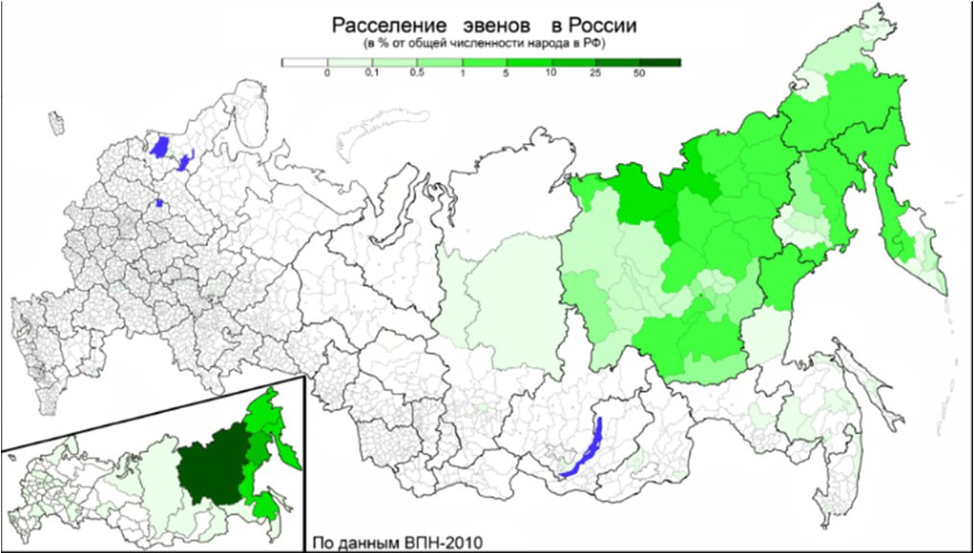
them to survive and look out for each other, even while they see their world for what it is. –p.376
Even population in Russia (in percentage of total population of region). According to the 2010 Russian Federation Census, 22,383 people self‐identified as Even. The blue on the map denotes lakes. Image from https://en.wikipedia.org/wiki/Evens#/media/File:%D0%A0%D0%B0%D1%81
%D1%81%D0%B5%D0%BB%D0%B5%D0%BD%D0%B8%D0%B5_%D1%8D%D 0%B2%D0%B5%D0%BD%D0%BE%D0%B2_2010.png

⁷ Shamanism is a practice where a person perceives and interacts with energies or entities of a spiritual world.
⁸ A gulag was a Soviet state‐run labor camp.

Appendix E3

Primary Source Analysis and Comparison

- Split your group in half. One half should read "Text A," and the other should read "Text B." One of the texts is by Zitkala Sa about one of her first days at an Indian boarding school in Wabash, Indiana. The work was published in 1900. The other is by Piers Vitebsky about the Even people, an ethnic group in Russia's Far East. The work was published in 2005.
- When you have finished reading your text:

  - Give a short summary of your source to the other half of the group.
  - Ask who is the author of this text and what do you know about him/her.
  - Ask about the author's purpose and intended audience of the reading.
  - Ask if the author has a bias. What bias might that be?
  - Determine if this a primary or a secondary source. How do you know?
  - Write your findings from your reading in your handout.

24

Appendix F1
Michael Wasson (Nimíipuu)

The Exile
Chilocco Indian School, Oklahoma, 1922: A disciplinarian says, There is no foolishness, do everything just so… such as keep your room clean, keep yourself clean, and no speaking of your Native language.

For now I can
just whisper
kál’a sáw

the ’óx ox ox
of your hím’ k’up’íp

wrecked at the base
of a century that burns through my slow blood
Translations:

kál’a sáw—just in sudden silence
'óxoxox —sound of bones and flesh tearing
hím’ k’up’íp—sound of a mouth breaking

/

kiké’t caught

kiké’t—blood silúupe—at or in the eye

in the blink silúupe

so draw the eyelids
shut & forget the fire tangled among the branches

of your spine
start where the skin meets

half an autumn
rusting the edge of winter that is knifing between me & ’iin you & ’iim ’ee

’iin—I

’iim ’ee—you (with emphasis)

/

boy have you forgotten us
is not what they are saying or are they asks another century
how are we remembered in our choreography
of bones?

/

mouth your birthplace boy
without mouthing off tim’néepe is at the heart

or the heart of the monster
or the grass blood-soaked

from the fresh kill that finally isn’t
your father

& pray héwlekce when your body is given away says the orphan boy

with lashes licked into his shoulders

forget ’im’íic because they can tear every lip from every memory

of your mother

/

because you are
torn & because you are what song fills
your throat with the color
of carved out tongue

peewsnúut & hi’lakáa’awksa
is what is voiced in the dark & so what does it mean
asks the boy

tim’néepe—at or in the heart, where the mind and felt emotions are housed. Also, the name of the Nez Perce creation site, Heart of the Monster, located in Kamiah, Idaho.

héwlekce—I disappear

’im’íic—your mom [more intimate] (as opposed to your mother)

peewsnúut—without tongue, or cut tongue, or removed of one’s tongue
hi’lakáa’awksa—he, she, or it is lit all through the night

/

as the moon glows mouth open to the unbearable taste of ash
blown among the stars

that the boy learned
the ghost’s trail

that milky way is lit by the dying brightly echoed

/

c’ewc’éewnim ’ískit
so there had to be breathing there had to be.
c’ewc’éewnim ’ískit—the ghost’s trail / the Milky Way

Appendix F2
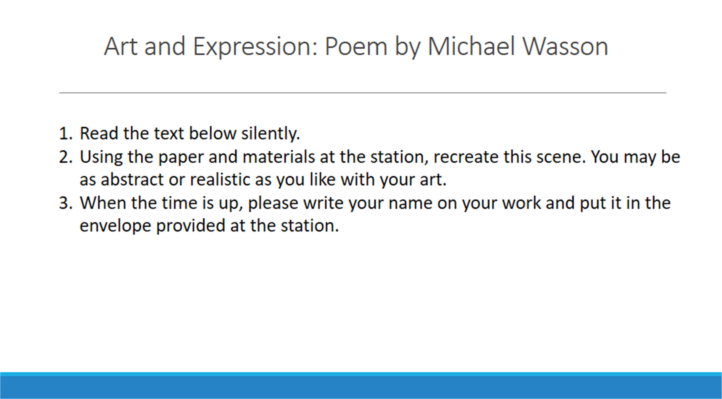

28

Appendix G1

Analyzing Before and After Photographs of Carlisle Indian School Students
Adapted from Carlisle Indian School Digital Resource Center | www.carlisleindian.dickinson.edu
“Under the authority of the US federal government, Carlisle [Indian School] was the first federally funded off‐reservation Indian boarding school. Founded in 1879 by Captain Richard Henry Pratt, it enrolled over 10,500 students by the time of its closing in 1918. Pratt believed that American Indians were the equals of European‐Americans, and that Native American children immersed in mainstream Euro‐American culture would become assimilated. To document his experiment, what scholar David Wallace Adams has referred to as ‘Education for Extinction,’ Pratt commissioned John N. Choate to take before and after ‘contrast’ photos to document the progress they were making in ‘civilizing’ the Indian children. These photographs were then sent to officials in Washington, to potential charitable donors and to other reservations to recruit new students.”
- Choose one of the before photos. Write five sentences describing what you see on the handout.
- When everyone has finished, uncover the corresponding after photo. Write five sentences describing what you see on the handout. Avoid comparing and contrasting the two photos.
- When everyone has finished, discuss the before and after photographs, comparing and contrasting them.
- This, and other before and after photos of Carlisle students can be found in many publications and on many websites, however there is very little information about them as students are as people. What might this tell us? Discuss.
- If you have extra time, write a summary of your discussions.

Appendix G2

Four Pueblo Children_Zuni Before
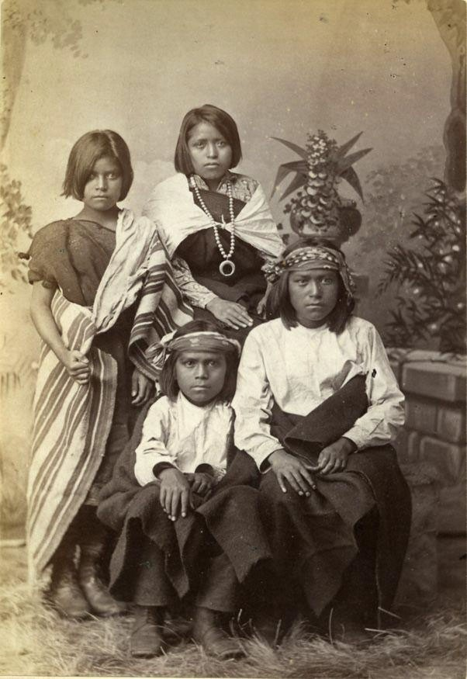

Appendix G3

Four Pueblo Children_Zuni After
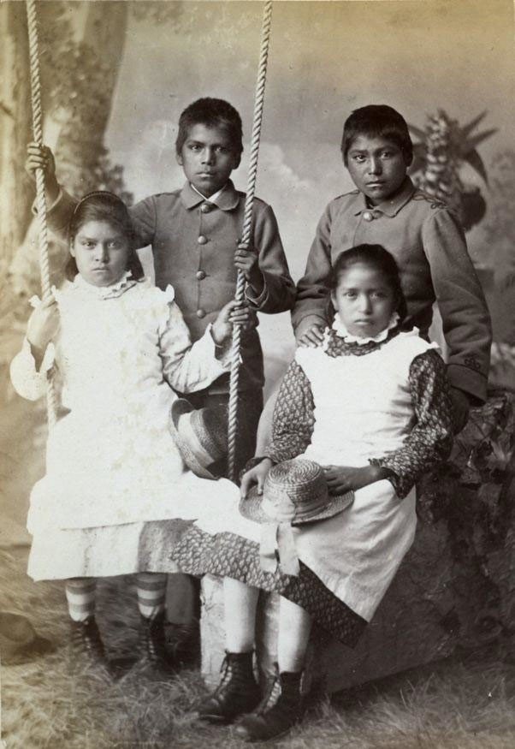

Appendix G4

Tom Tornilo Before
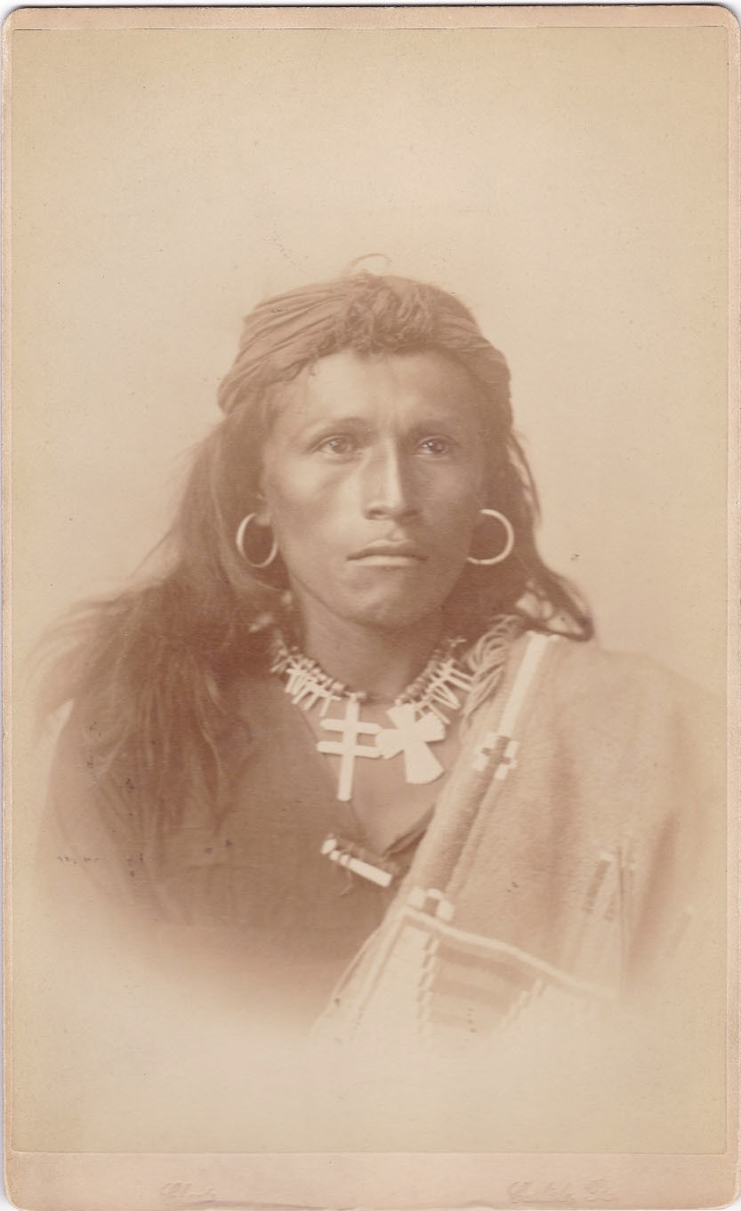

Appendix G5 Tom Tornilo After
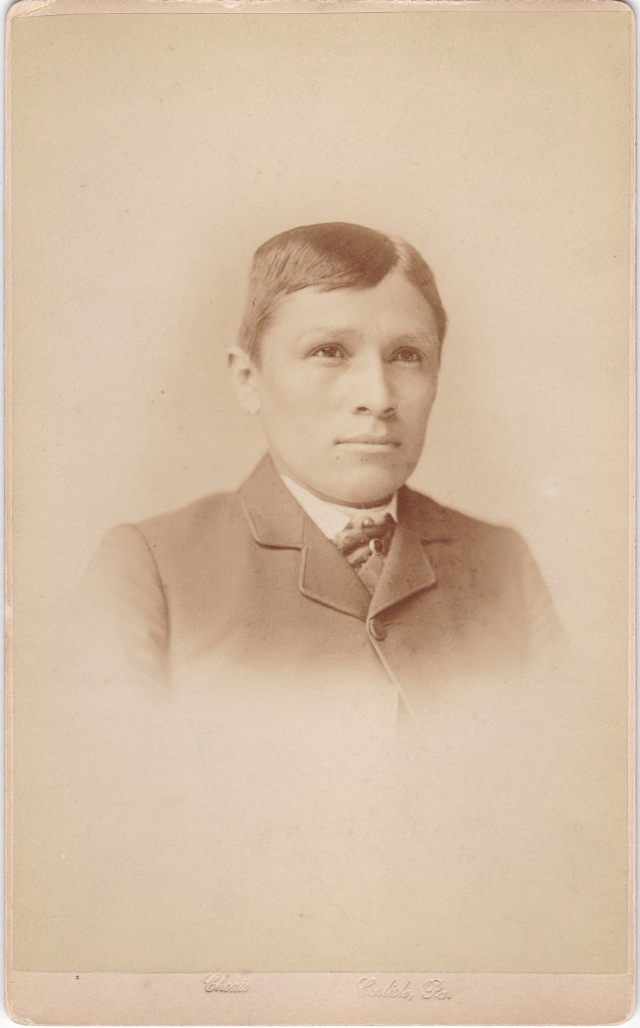

Appendix G6

White Buffalo 1881 Before
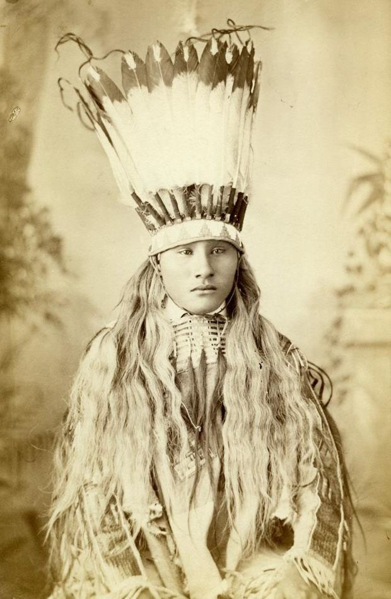

Appendix G7

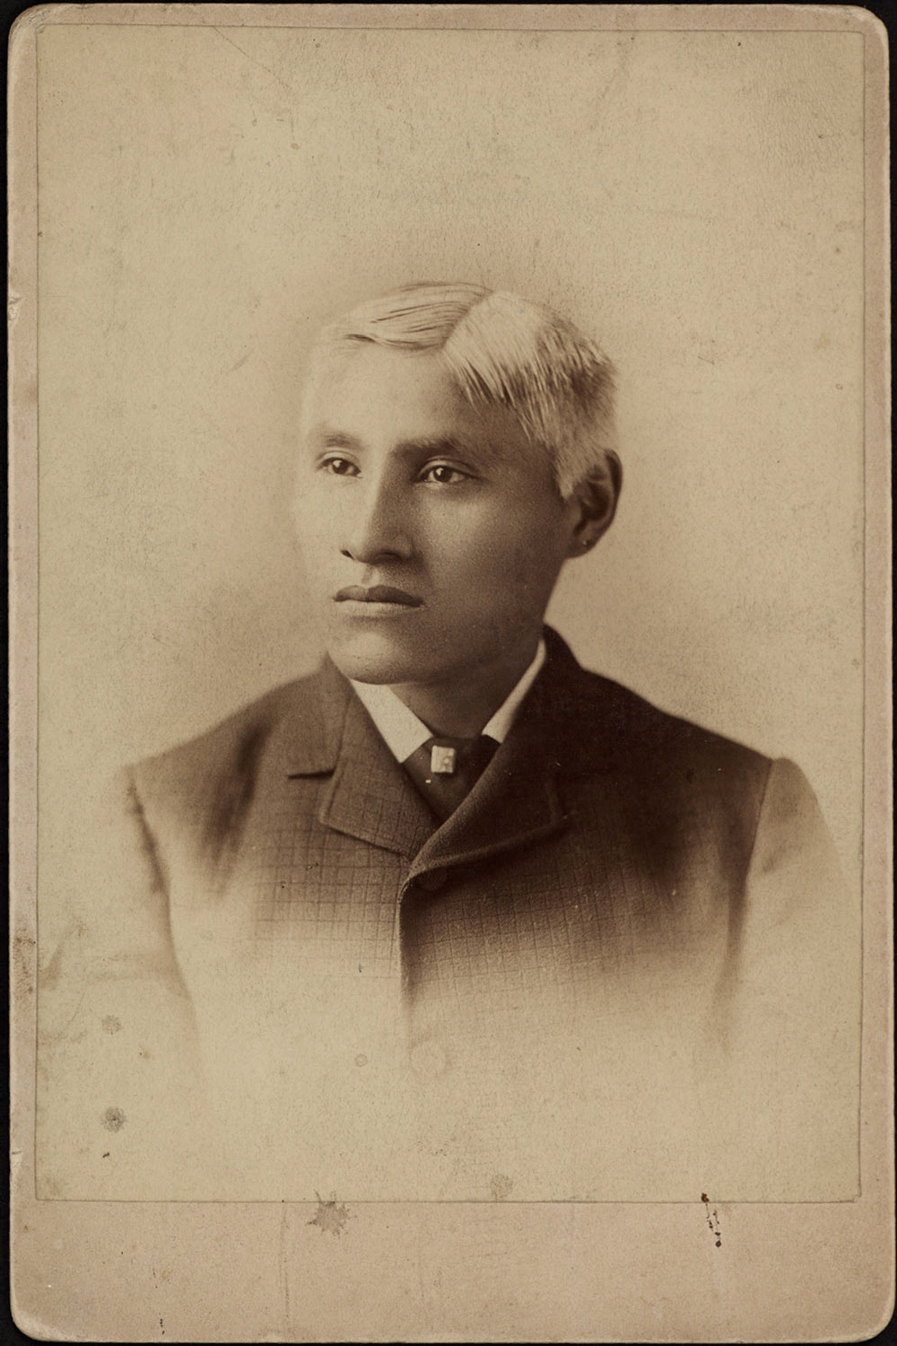
White Buffalo 1881 After

Appendix G8

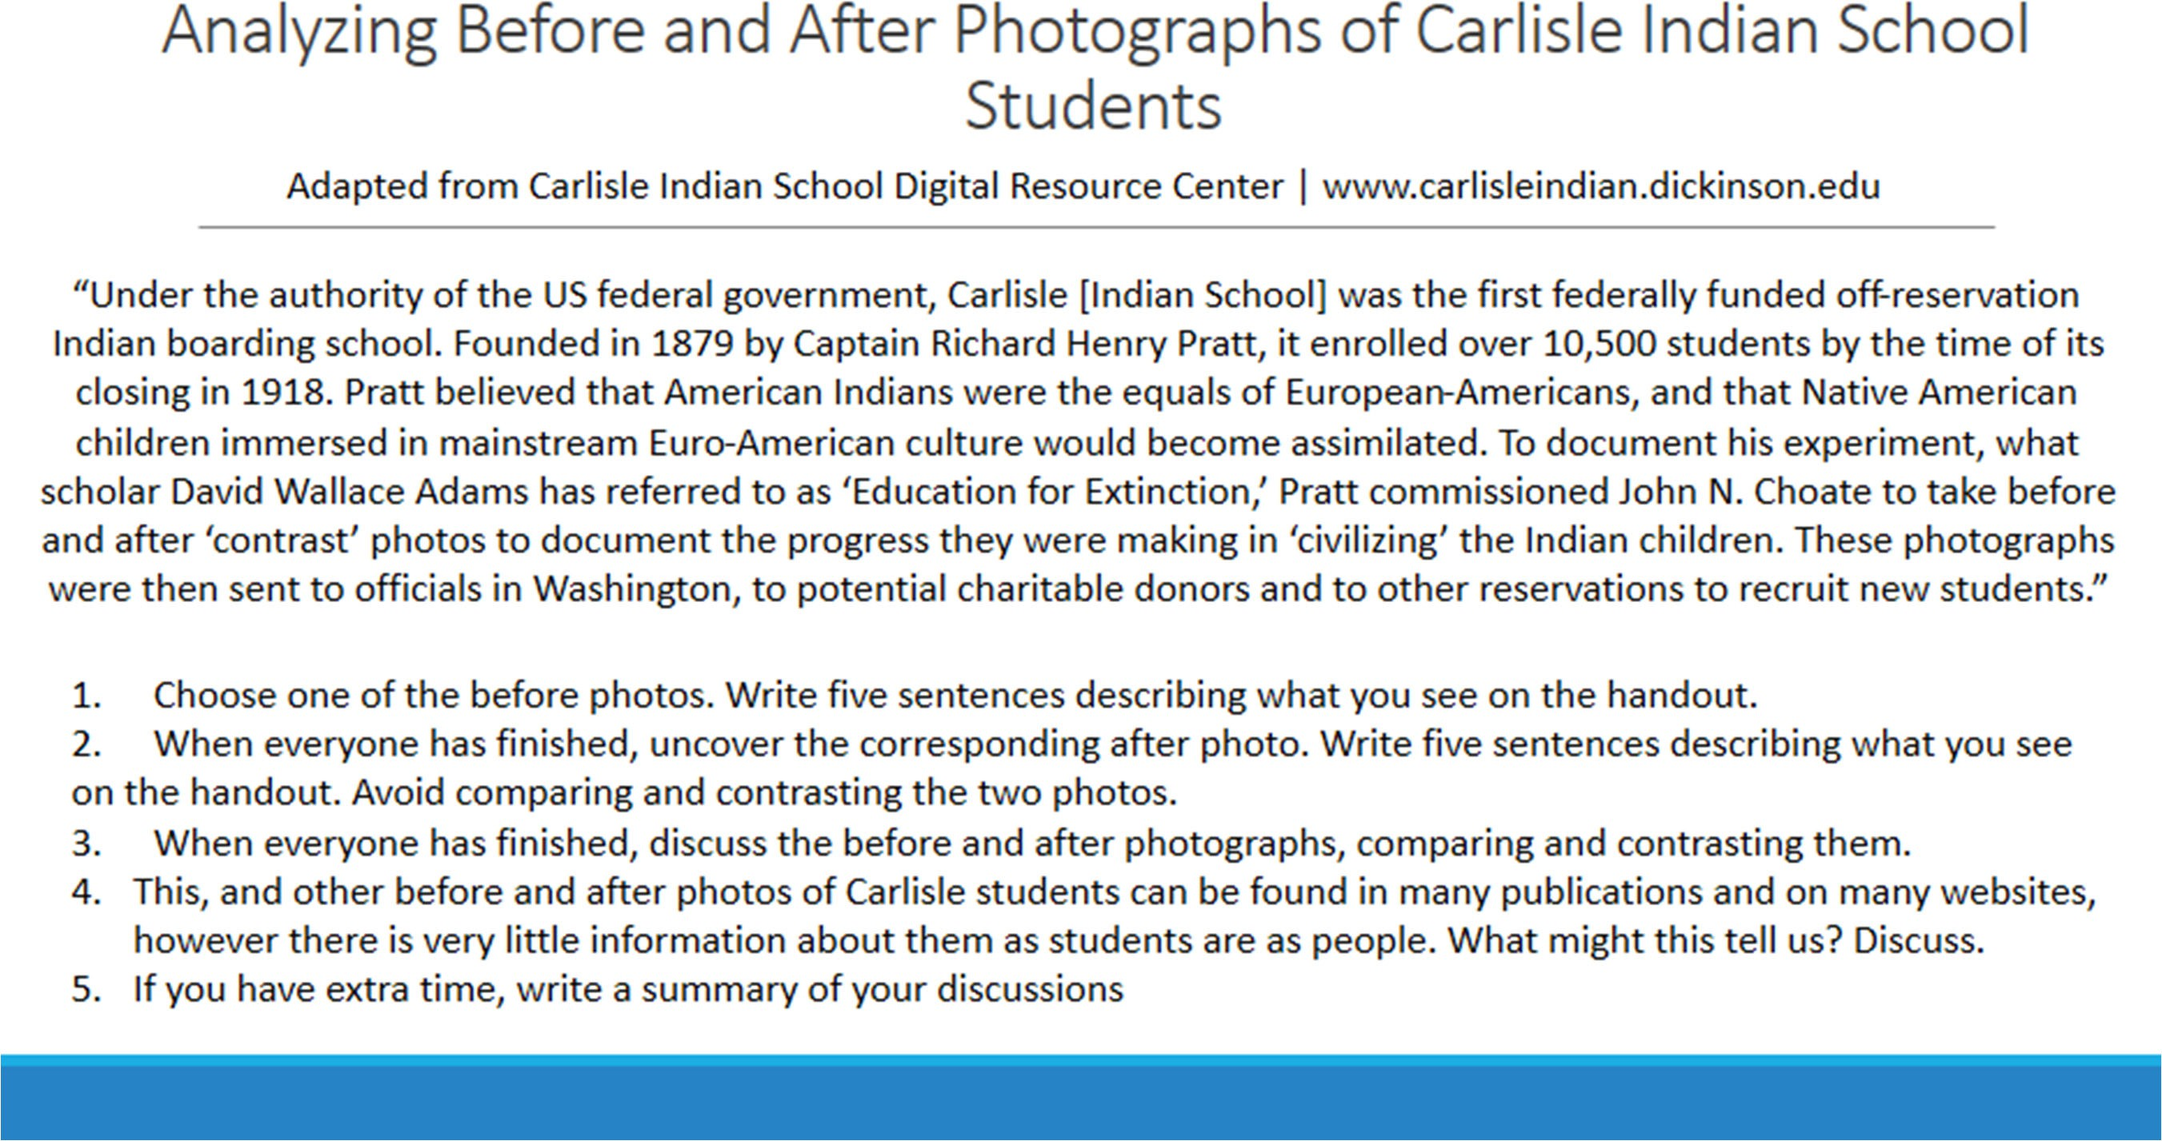

36

Appendix H1
Arigon Starr‐ Please Don’t Touch the Indians
Lyrics and text from https://www.arigonstarr.com/lyrics_all/red_road/pleasedonot.html and https://www.arigonstarr.com/Diva/dox/arigonbio.html

Arigon Starr is an enrolled member of the Kickapoo Tribe of Oklahoma. Starr grew up on the road as part of a military family. Her parents, Ken Wahpecome (Kickapoo) and mother Ruth (Creek‐Cherokee‐Seneca) supported her artistic expressions, encouraging her to learn as much as possible about music, composition, art, and drama. Starr relocated to Los Angeles, where she worked behind the scenes at entertainment companies like Viacom Productions and Showtime Networks. In 1996, she left her corporate job behind and became a full‐time musician.

"Things are getting a little better in Hollywood," mused Arigon. "At least producers make an effort to cast Native people in Native roles." The history of Hollywood is full of folks like Jeff Chandler playing Cochise. Yet even today, there are some "Native" actors on‐screen who change their tribal affliation as often as some folks change their socks. "The only solution for this is for Native people to make their own films and TV shows," said Arigon. "I can only hope we show our people and ancestors more respect than some of the big budget projects that are out there today."

They put a white guy in tan make‐up They put a black wig on his head
It's no wonder we ain't on tee‐vee They all think we're dead

They write songs and they make movies About Indians long ago
All those pictures never look like Indian folks I know

CHORUS

Please do not (Please do not) Touch the Indians
It's my world My only home
Please do not (Please do not) Touch the Indians Way‐ya‐hey‐ya Way‐ya‐hey‐yo

Old time westerns show warriors As fools and as liars
Cartoon Indians dancing 'round A captive set on fire

A producer takes a call From a studio on the phone
They want him to make "Geronimo" With Sylvester Stallone

CHORUS

Please do not (Please do not) Touch the Indians
It's my world My only home
Please do not (Please do not) Touch the Indians Way‐ya‐hey‐ya Way‐ya‐hey‐yo

A so‐called expert gave Hollywood Knowledge that was a gem
"The best way to learn their history Is to tell it all to them."

Don't expect to do much learnin' From movies or tee‐vee
They'll put tipis in Seattle Or Buffaloes in Chinle

Questions:
What are your general impressions of the song?

What is the mood of the song? Do you think this song has a message?

Describe some of the sounds from the song. What instruments were used? Was it upbeat or more melodic?

Why do you think it was important for Starr to create a song about Hollywood and advertising portrayals of indigenous Americans?

Have you seen any of the images described by Starr? How could they be improved?

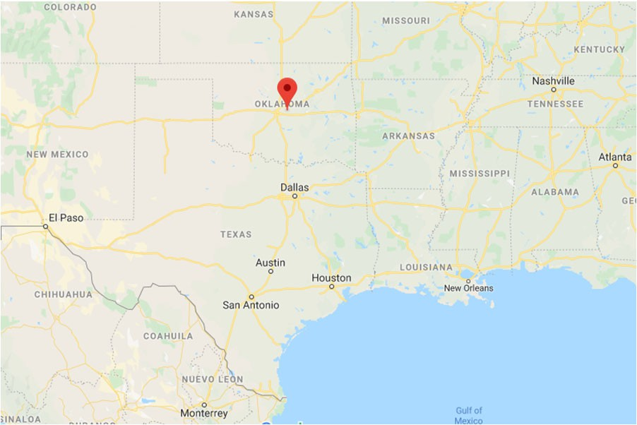
The red pin is McLoud, Oklahoma. Today the Kickapoo Tribe of Oklahoma is headquartered in McLoud, Oklahoma.

Appendix H2

KEiiNO – Spirit in the Sky

“Spirit in the Sky” was performed by the Sami‐Norwegian music group KEiiNO, which represented Norway in the 2019 Eurovision Song Contest. The group NEiiNO consists of Sámi rapper and joiker Fred Buljo, and Norwegian singers Alexandra Rotan and Tom Hugo. Some lyrics of “Spirit in the Sky” are in the Northern Sami language. “Čajet dan čuovgga” means "Show me the light.” “He lå e loi la” is traditional Sami joik, which can be compared to the traditional chanting of some North American indigenous cultures. Joiks can reflect or evoke people, animals, or places.

The Sámi people (also spelled Sami or Saami) are an indigenous Finno‐Ugric people which have historically lived in northern parts of Norway, Sweden, Finland, and the Kola Peninsula of Russia. Sámi are also historically known in English as Lapps or Laplanders.

Lyrics (Sámi & English):

Verse 1
Can’t you stay, stay with me into the night? Stay, I need you close
You can go back when the sun rise again Just stay tonight, just stay

Have you seen my spirit, lost in the night?
The violent nightshade, they took away my light They call us nothing, my name is nothing
Come see me, please see me

‘Cause I’ve been running with the demons now They all see my fear
They say there’s nothing, nothing here

Bridge
I see your spirit in the sky
When northern lights are dancing He lå e loi la

Chorus
I hear you calling me at night Whenever wind is blowing He lå e loi la
I can see your spirit in the sky When northern lights are dancing He lå e loi la
Čajet dan čuovgga

Verse 2
I’ll follow you until the daylight Shy us away

I need a hero, I need my light
Her shining lightwaves will break away the night I call it freedom, our name is freedom
Come find me, please find me

Bridge
‘Cause I am dancing with the fairies now They all sing our name
I got my light here, shining here

Chorus Chorus Chorus

QUESTIONS:
What are your general impressions of the video?

What is the mood of the video? Do you think this song has a message?

Describe some of the images from the music video. What were the artists wearing? What were they doing?

Describe some of the sounds from the song. What instruments were used? Was it upbeat or more melodic?

In a post on Instagram, KEiiNO wrote that the song is “a story set in Sápmi many years ago, where a person is calling upon hers/his helping spirit for extra strength

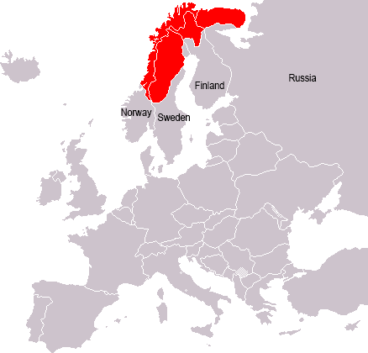
Areas where Sami have traditionally lived. Image from https://www.offthemap.travel/news/who‐are‐the‐sami‐people/

in a difficult situation. According to pre‐Christian Sami religion, the people had helping spirits. These could be in the shape of an animal, called Sáivu‐loddi or Sáivu‐sarvvát.” What helping spirits do you see represented in the music video?

Appendix H3 Nadjiwan‐ Generations
Born in northern Manitoba, Canada, Marc Meriläinen, also known as Nadjiwan, has been active in music for over 25 years. Having known that he would be part of the music scene at a young age, Nadjiwan graduated from Music Industry Arts program at Fanshawe College and immediately became involved with musical projects and collaboration with other First Nations artists in Thunder Bay. Nadjiwan’s first CD was released in 1995 and achieved success in North America, winning him the first album spot on the Aboriginal Voices Top 10.
Nadjiwan is of Finnish and Ojibway descent and often incorporates indigenous instruments from both Scandanavia and the Americas into his rock sound. Generations is the title track of his 2019 album.

Lyrics:

Power is given to us Try and use it well
Cherish what surrounds us Hold this land sacred
Know of our limitations and know of our place in the circle (in the circle…)

Lifeblood flows through these veins giving us all that we need
Providing us with sustenance, satisfying our basic pleasures
Without you I cannot survive Without you I have no hope

Generations
We’ve been here for Generations
And we’ll continue to remain for Generations (generations)
Repeat

Through the Trail of Tears to the Reconciliation Years
We still stand tall
From indignation to legislation, we’ve survived it all
The path has been chosen for us and lay before our eyes
And the time has come, the time has come for this generation to rise

Generations
We’ve been here for Generations
And we’ll continue to remain for Generations (generations) Repeat

Questions:
What are your general impressions of the video?
What is the mood of the video? Do you think this song has a message?
Describe some of the images from the music video. What do you see? Are the images at the beginning of the video different from those at the end? Which images stood out most to you?
Describe some of the sounds from the song. What instruments were used? Was it upbeat or more melodic? Describe the “singing” in the song.
Nadjiwan’s son, Cole Rivers, played percussion on this track. How does this information, if at all, affect your response to the song?
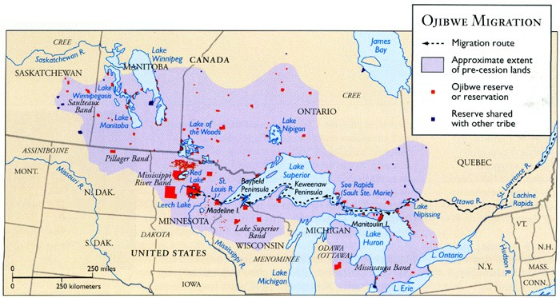
Map of Ojibwe reservations and traditionally‐occupied lands. Map from http://geo.msu.edu/extra/geogmich/ojibwe.html

Appendix H4

Pamyua‐ Bubble Gum
Text from https://www.youtube.com/watch?v=Z7U5GCrMWOo

Bubble Gum is from Pamyua's (pron: BUM‐you‐wah) album SideA/SideB. This drumsong commemorates a student in band member Ossie's dance class who was chewing gum when he wasn't supposed to.
Pamyua's double album SideA/SideB is a collection of Inuit drumsongs primarily sung in the Yup'ik and Cup'ik language from Southwestern Alaska. Inuits are a group of culturally similar indigenous peoples which have historically lived in the Arctic regions of Greenland, Canada, Alaska, and Russia. Drum songs are powerful expressions of Inuit creativity and connection to our Arctic environment. SideA/SideB offers a new approach to appreciate Inuit music. SideA (disc 1) honors Inuit tradition by featuring only vocals and Inuit drumming; SideB (disc 2) has the same songs with different world music arrangements.
This music video was shot in Unalakleet, Alaska during the filming of the Discovery Channels show Flying Wild Alaska season three by Anchorage‐based film collective Electric Igloo Creative.
Lyrics (Yup'ik / English):
Chorus
Tamualua yagiralua / Chewing as I dance X2 Pagaaggun‐qaa un'gagun‐llu / Up there and down there Akulikun‐llu alairtuq‐gguq / In the middle he appears Tamaksuarluni / Chewing

Verse 1
Pagkumiu ilagaraakut / Person from up north joined us Yagirainanrani ellagnuqiigna / While he is dancing he becomes aware Pagaaggun‐qaa un'gagun‐llu / Up there and down there
Akuliikun‐llu alairtuq‐gguq / In the middle he appears Tamaksuarluni / Chewing
Verse 2
Talluryugnerma yagirayaaqua / Even if I am embarrassed I try to dance Tamualua yagiralua / Chewing as I dance
Pagaaggun‐qaa un'gagun‐llu / Up there and down there Akuliikun‐llu alairtuq‐gguq / In the middle he appears Tamaksuarluni / Chewing

Questions:
What are your general impressions of the video?
What is the mood of the video? Do you think this song has a message? Why do you think the band performed this song about chewing gum?
Describe some of the images from the music video. What were the artists wearing? What were they doing? How do they dance?
Describe some of the sounds from the song. What instruments were used? Was it upbeat or more melodic?
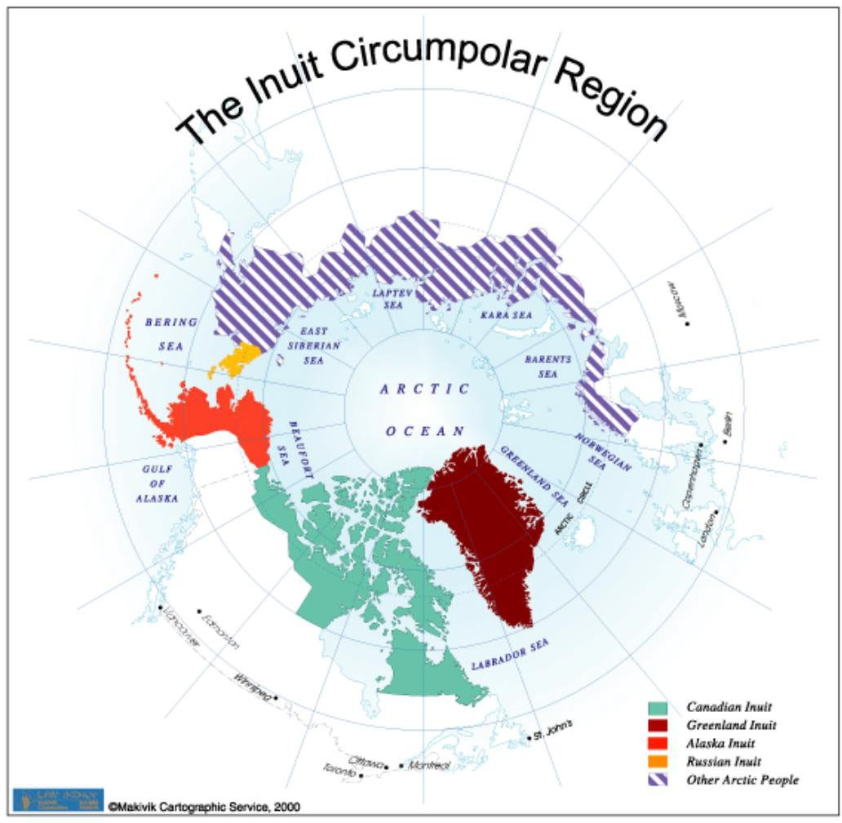
Image from https://twitter.com/dimmerwahr/status/1124418433435697153

Appendix H5
Prolific the Rapper‐ Black Snakes
Parts of text from https://prolifictherapper.com/bio

Prolific is an Indigenous Hip Hop and film artist currently based out of Rapid City, SD. He is a member of the Rosebud Sioux Tribe. He was recently active in the NoDAPL Indigenous resistance movement at Standing Rock, ND and that is where much of direction manifested. While there, he recorded a music video "Black Snakes" that went viral twice on Facebook and Youtube for a total of more than 2 million collective views. This is the video you will be watching.

Lyrics:
[Intro] One family
If we don't stand, who will?
One Earth

[Verse 1]
The wind comes in four corners Four directions, four colors And death rides on 4 horsemen
A black snake with some black tanks (ugh) How much money do these companies need to make?
They could drive their product But they want to save a buck Already extracted billions When is enough, enough?
I used to be in the oil fields, getting paid But I quit, 'cause oil‐water I can't drink Looked down and seen Kimimila die in the mud
I looked up and told myself that enough's enough
Money does not own my soul, living comfortable
Is not in my plans, my hands in the sand Some things worth more than gold Some things they can't be sold
Some things can't be replaced

She is your mother, the fresh water is her veins

[Bridge]
Turtle Island, not black snakes The fresh water is her veins
What is going on have we all lost our minds?
Every human needs clean water to survive

[Verse 2]
Love is the strongest This path is the hardest
But if we weren't strong enough to do it we wouldn't see it
Our prayers would not be needed This movement's very needed Indigenous wisdom unheeded And sacred things depleted
I'm Mexicano, I’m Lakota, and I'm white, too
I'm mixed with everyone So part of me's just like you
Every group of human beings shares the same stars
And if the earth is not your mother Are you from Mars?

[Bridge]

This side of the planet's been in decline since 1492
500 years and counting
Surviving the genocide they call "colonizing my Turtle Island”

[Verse 3]
What is a fossil fuel?
Continued destruction, nothing new Live in a system
Taking our children Shifting their feelings Till nothings true
I had that money in front of me but I left it 'Cause oil money's dirty if my Mother gets disrespected
We're disconnected, these times are hectic And feeling heavy
But we still love all living beings And suffer for the many
We are a peaceful people That's why we walk with prayer And if that wasn't true
We wouldn't be standing here

[Outro]
We're peaceful people Who walk with prayer Turtle Island, have no fear
Despite what they show in the media We're kind people, hold your ground Change is coming now

QUESTIONS:
What are your general impressions of the video?

What is the mood of the video? Do you think this song has a message?

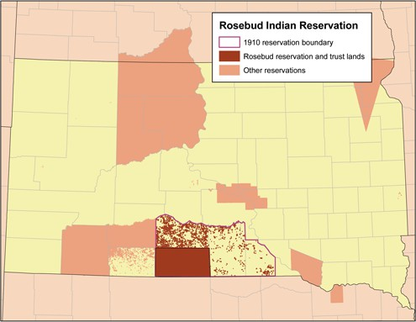
Why do you think it was important to Prolific to write this song and make this music video?

Describe some of the images from the music video. What do you see? Are the images at the beginning of the video different from those at the end? Which images stood out most to you?

Describe some of the sounds from the song. What instruments were used? Was it upbeat or more melodic? Describe how voice is used as an instrument in this song.

South Dakota, USA. Image from https://kids.kiddle.co/Image:Rosebudreservationmap.png

Appendix H6
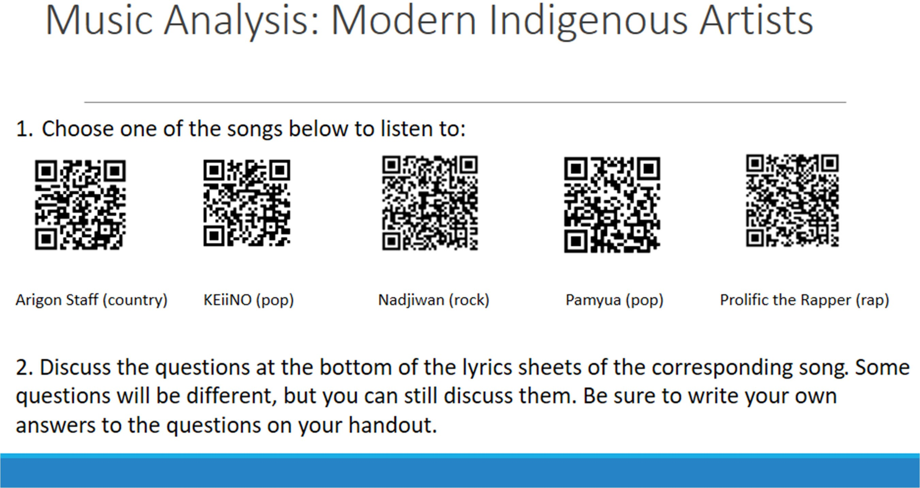

Appendix J
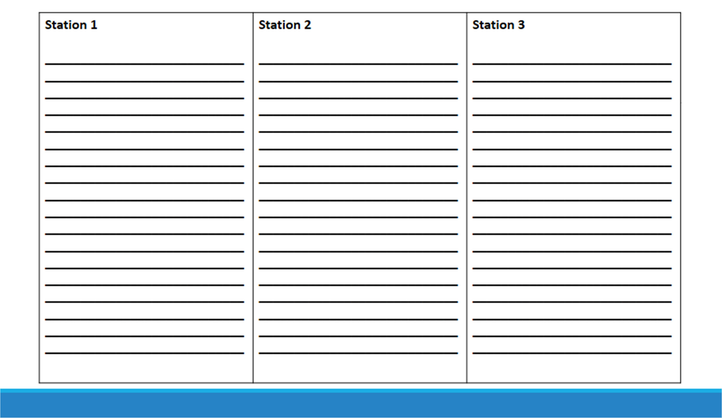

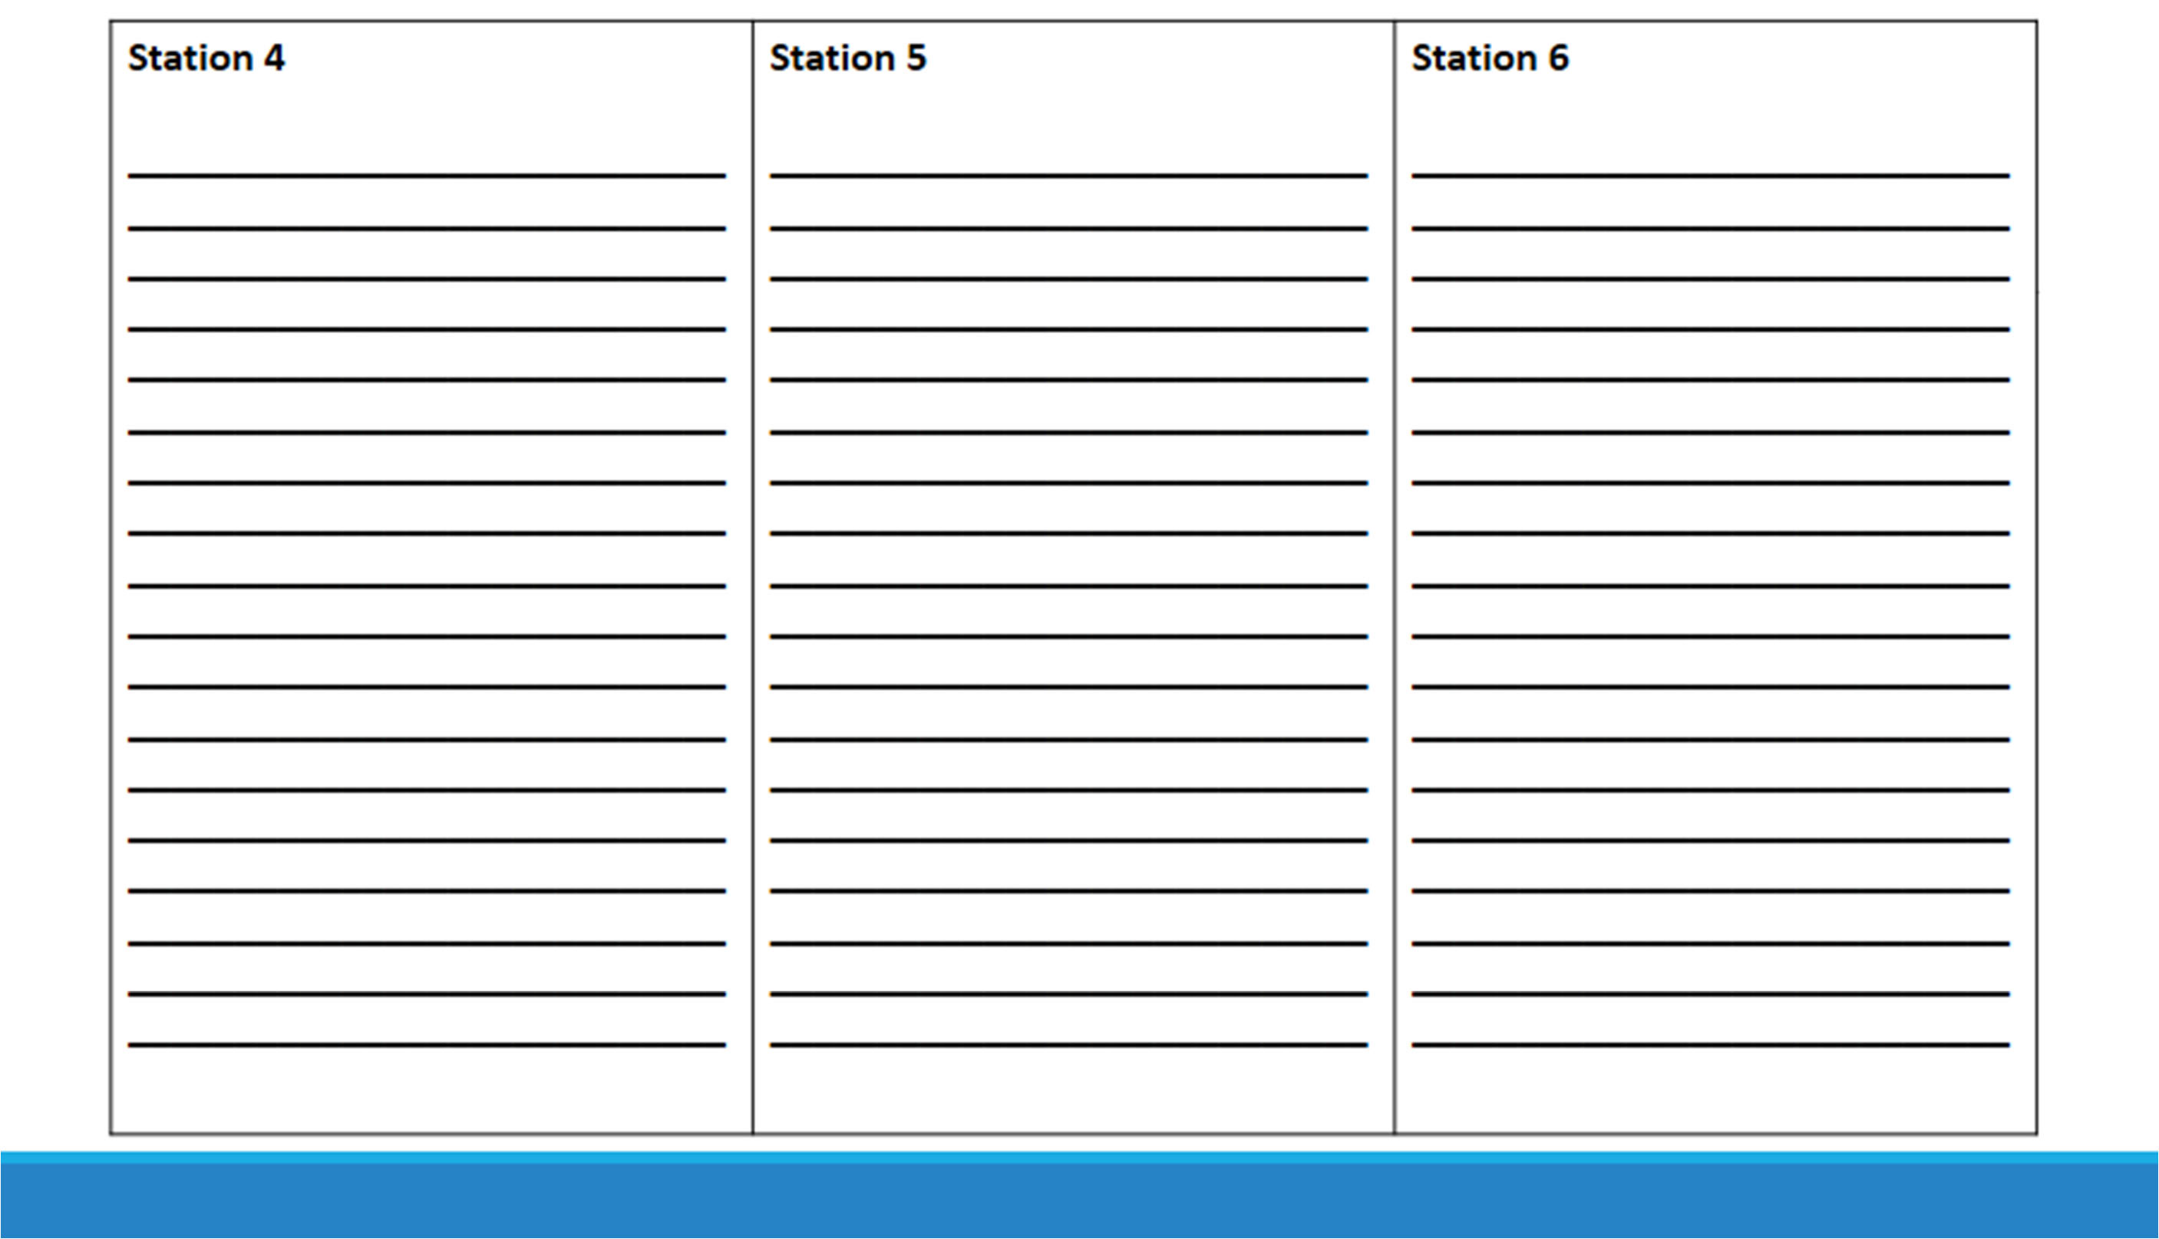

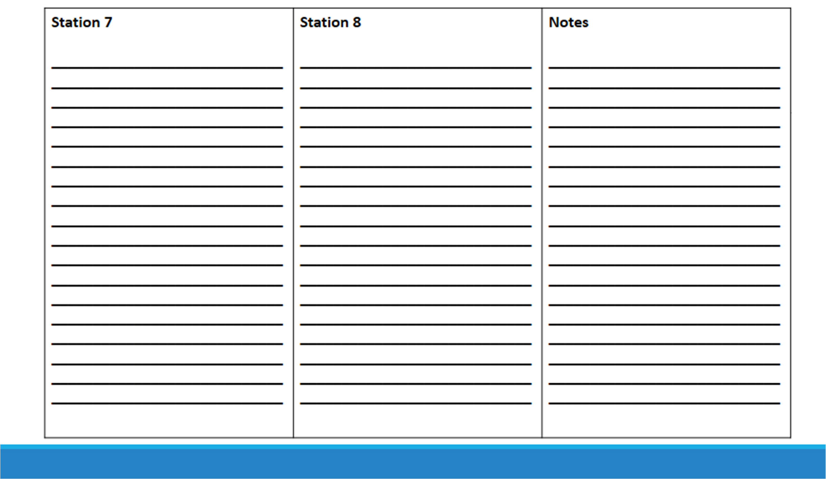

Appendix K
Name, Class Period:
Address the Following Question: How do events which occurred generations ago affect indigenous communities in Russia and the US today? Compare and contrast various US and Russian policies, their effects, and ways indigenous communities in those countries are overcoming those challenges. Use information learned in class and find additional materials to support your claims.

 | Beginning  1 | Developing  2 | Acceptable  3 | Accomplished  4 | Exemplary  5 | Score
Purpose & Supporting Details | The blog only addresses US or Russian policy towards indigenous communities | The blog addresses US and Russian policy towards indigenous communities but does not contain supporting information. | The blog actively compares and contrasts US and Russian policy towards indigenous communities with supporting information, such as offering examples, but fails to address how those policies are current affecting the relevant communities or how those communities are addressing those effects. | The blog expertly compares and contrasts US and Russian policy towards indigenous communities by using supporting information, such as examples from the stations. The blog also addresses how those policies currently affect indigenous communities and how communities are addressing those effects. | The blog expertly compares and contrasts US and Russian policy towards indigenous communities by using supporting information, such as examples from the stations and an example from the students’ own research. The blog also addresses how those policies currently affect indigenous communities and how communities are overcoming challenges brought on by such policies.
Organization | The blog is unclear and unfocused. No style is identifiable. The organization of the blog causes the reader to become confused. No transitions are used. | The organization of the blog does not fit the blog style or is not consistent. The blog might not have a clear introduction or conclusion, or the structure of the blog might cause the reader to have trouble following the blog. Transitions are rare. | The organization generally fits the blog’s styles. The flow of the blog is logical, but might be repetitive. It might be hard to understand the blogger’s conclusions. Transitions are used to connect themes. | The organization fits the blog’s style. Ideas are grouped logically. The blog moves between ideas using effective transitions to connect themes. The blogger’s conclusions are clear. | The blog’s organization supports the blog’s style in a consistent manner. Ideas are focused and grouped logically. The reader understand the blogger’s conclusions. The blog moves smoothly between ideas and uses various transitions to show how events or themes are connected.
References & Additional Content | The blog contains 0-1 references of any information from the stations. | Student has referenced information from 2-3 of the stations visited. | Student has referenced information from 3-4 stations visited | Student has referenced information from most stations visited and included references to other materials found on own time. Little bibliographical information on the  referenced material is added, for example, online links only. | Student has referenced information from all stations visited and included references to other materials found on own time.  These additional materials can be easily found thanks to bibliographical entry.
Grammar | Full of mistakes, making it hard to  understand or follow. | Numerous mistakes, but readers are able to follow the main  ideas. | Few mistakes. The reader is able to engage in the blog. | 3-4 mistakes. | Zero mistakes.

Additional Comments:

