# Indigenous American and Siberian History and Residential Schools Lesson Plan

I’ve heard the phrase, “history repeats itself,” but it wasn’t until I studied indigenous history in Russia that I noticed the parallels between events which occurred in the US, Russian, and Canadian contexts concerning indigenous groups within their borders. As your students will discover, several governmental policies, including forced resettlement and residential schooling participation, occurred in both the US and Russia, and indigenous communities in both countries are still dealing with the consequences of those policies today. This unit focuses on Indiana state standards for 4th graders in timeline creation, comparing and contrasting events, and parts of Indiana statehood history. This lesson plan has extension sections for 1.5 hours class periods. Educators may adopt the activities or readings for use in a lesson plan of their own or they may use the lesson plan in full. Please see Appendix G for more materials and resources to expand this lesson plan.

It is important for students to understand how the United States was formed and how those early policies differed and were similar to other policies around the world. Students should realize that history is always seen through a lens, and hopefully this lesson plan will let them identify that lens when continuing their studies on early US history. I hope that this lesson will make students interested in new spaces, both domestically and abroad. Russia and the United States are more similar than we realize.

**Objectives:** By the end of this lesson, students should be able to...

* Create and interpret timelines that show relationships among people, events, and movements in the history of the United States, especially Indiana, and Siberia, Russia.
* Identify and compare events in indigenous history in the region that became Indiana and the region that became Siberia regarding contact with Europeans.
* Identify and explain the causes of the removal of Native American Indian groups in the state and their resettlement during the 1830s
* Understand the role of indigenous boarding schools in Native American and Siberian history
* Understand the role of fur in European history of North America and Siberia
* Compare and contrast policies of resettlement and residential schools of the United States and Siberia

# Indiana State Standards and Indicators Addressed:

* Chronological Thinking, Historical Comprehension, Analysis and Interpretation, Research
  + 4.1.15 Create and interpret timelines that show relationships among people, events, and movements in the history of Indiana.
* Statehood: 1816 to 1851
  + 4.1.5 Identify and explain the causes of the removal of Native American Indian groups in the state and their resettlement during the 1830s

**Overview:** Students will read and discuss articles, create timelines, complete a Venn diagram, and will work as a class to complete a sort of KWL chart. Students will be working with articles in groups on indigenous history of the US and Russia with special attention paid to forced resettlement and residential schooling.

**Supplies Needed:** Print-outs of the Appendixes to be used; paper for students’ timelines; colored pencils, markers, or other colorful writing material for timeline comparison (extension); student journals or paper for KWL charts; large sheet of paper or smart board for group KWL chart (extension).

**Pre-requisite knowledge**: Students should know and understand that there is a country called Russia, and that it is actually very close to the United States. They should also know US geography. While knowledge of early US history and Indiana history is helpful, it is not necessary for this lesson.

**Warm-up:** On the board write the word, “Russia.” In their journals or on a piece of paper, ask students to write everything they know or think they know or have heard about Russia. If you like, you can show the class Russia on the map. If students know nothing about Russia, you can have them write what they might think Russia is like based on where it is in the world.

*Extension:* When enough time has passed, come together with your students and write on a large sheet of paper (or on a smart board- you’re going to come back to this list at the end of the lesson as a sort of KWL chart thing) some of the things they wrote.

**Introduction of the Topic**: Explain to your students that you are going to be comparing, or finding things that are the same, between two groups: indigenous communities of the continental US and indigenous communities of Siberia, a part of Russia.

*If students don’t know the word indigenous:* On the board write the word “indigenous”. At first, see if any of your students can give a definition. Explain to them that indigenous is an adjective used to describe nouns that are native or were the first to be in an area. Native Americans/First Nations/Indians are indigenous people to Indiana. Native Hawaiians are indigenous people to Hawaii. Plants can be indigenous to an area, too.

Buckeye trees and elderberry bushes are indigenous to Indiana. Just because something is indigenous, though, doesn’t mean it can’t be found in other places. For example, tomatoes are from west South and Central America. Today tomatoes are grown all around the world are used in Italian, Indian, and West African dishes. However, they are still indigenous to South and Central America. The tomato originated from South and Central America.

Tell students that you are going to compare events between these two people by breaking into 4 groups. Each group will read on a different topic: early indigenous history in the US, boarding schools for US indigenous children, early indigenous history in Siberia (a part of Russia), and

boarding schools for Russian indigenous children. In their groups they will read their article and then will be asked to draw a timeline of important events from the article.

*If students don’t know what a timeline is:* Explain that a timeline is a visual representation that shows events in chronological order, or in the order they occurred. We know that tomatoes are an indigenous plant to the Americas, but that they are now used all over the world. Let’s look at how the tomato became introduced to other cuisines using a timeline. See Appendix A for a timeline of the tomato’s journey and walk students through it. You can also pick a timeline on information you’ve previously covered in class.

**Activity:** Pass out Appendix B, C, D, and E to students, and place students with the same article in the same group. Appendix B is the longest of the articles (543 words), but it contains information that might be review if early US history has already been covered in class. Appendix C and E contain about 300 words and Appendix D contains 425 words. You may distribute the handouts at random or create groups based on reading level. When groups are finished reading the article, have them create a timeline together based on important information from their article. There are also two questions posed at the end of each article. If groups are waiting for others, have them either write answers to the questions in their journals or discuss the answers.

*Extension:* When you feel that enough time has passed, have groups with the US articles and the Russian articles merge their timelines, creating two groups and two timelines.

**Analyze**: If possible, project the student timelines, making sure the events are in chronological order. As a class, talk through or have students write answers to analysis/discussion questions. These questions require students to know the information included in all of the articles, so if students are writing answers, they will need to work in groups. Analysis/Discussion Questions include:

* Compare how the French in North America and how the Tsardom in Siberia obtained furs. Why were furs important? Why do you think Europeans traveled so far to obtain furs?
* How was the French and Indian War different from the Russian conquest of Siberia? Were there any similarities?
* How were the boarding schools in the US and Siberia different? Were there any similarities?
* What would it be like to live in an indigenous boarding school?
* Do you think it is important for children to live close to their families?

*Extension:* If there’s time, have students create a new timeline on their own, with Siberian events in one color and mainland US events in another, or as a class create a new timeline with two colors to represent the US and Russia contexts

**Wrap-up:** Get back out the large sheet of paper that was used to write what students think they know about Russia (extension). Have students write out what they learned about Russia in their journals/on their papers and then come back together as a class and ask them what surprised them about this lesson. Use this time to solidify that the US and Russia have a lot in common. They are both multiethnic/linguistic/religious countries made up of smaller states (US) or okrugs (Russia) or regions. They both had similar policies on indigenous people.

Scientists today even believe that indigenous Russians are related to indigenous Americans!

**Possible Extension**: Have students create a Venn diagram about what they learned about the similarities and differences between mainland US and Siberian indigenous history. They can also write a paragraph based on the diagram.

**Modification for advanced/less advanced students:** For more advanced students, have half of class read articles B & C and the other half read D & E. Ask more in depth questions during the wrap-up. For less advanced students, choose to have the class read only article B & D or C & E and have the class compare those two sections.

**Homework**: assign a book report (see Appendix G for book list); assign article on the Chukchi and answer questions on the article (see Appendix F). Appendix F can also be used as an extension.

Appendix A: Tomato Timeline

700 AD: tomatoes are used by early Aztecs (indigenous people of southern Mexico)

1590s: Tomato begins to be grown in Britain

1801: Tomatoes are added to the mushroom ketchup recipe

1897: Joseph Campbell figures out how to can tomatoes and creates condensed tomato soup

1500s: Spanish explorers come to Central America and bring tomato seeds back to grow the plant for decoration

Late 1700s: Most Europeans fear the tomato, because the leaves and stalk of the plant are poinsonous and because the acidity in the tomato would react with the dishes used at the time, poisoning people

1880s: Pizza is invented in Naples and tomatos become a staple in Italian cuisine

early 1900s: Heinz begins making tomato ketchup that we would recognize today

Information taken from: <https://www.tomato-cages.com/tomato-history.html>; [https://www.smithsonianmag.com/arts-culture/why-the-tomato-was-feared-in-europe-for-more-than-](https://www.smithsonianmag.com/arts-culture/why-the-tomato-was-feared-in-europe-for-more-than-200-years-863735/) [200-years-863735/](https://www.smithsonianmag.com/arts-culture/why-the-tomato-was-feared-in-europe-for-more-than-200-years-863735/) ; [https://www.nationalgeographic.com/culture/food/the-plate/2014/04/21/how-](https://www.nationalgeographic.com/culture/food/the-plate/2014/04/21/how-was-ketchup-invented/) [was-ketchup-invented/](https://www.nationalgeographic.com/culture/food/the-plate/2014/04/21/how-was-ketchup-invented/) ; <https://www.thespruceeats.com/ketchup-catsup-history-1807618>

Appendix B: Native and Indigenous Communities in the United States: Beginnings to 1830 (543)

# Native and Indigenous Communities in the United States: Beginnings to 1830

At the end of the Ice Age, humans first came to North America across a land bridge that existed between the lands known today as Chukotka, Russia and Alaska, United States.

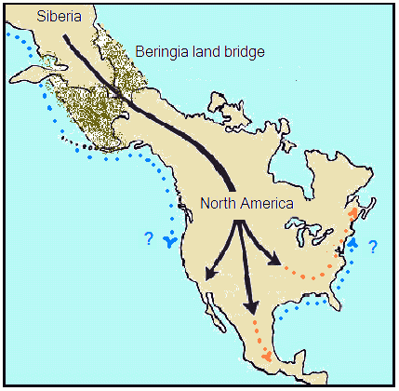

*Scientists today believe indigenous Americans migrated from the area known today as Siberia through the Bering Strait 15,000-30,000 years ago. At that time, there was land and ice between the Chukot peninsula and Alaska, making travel possible. Image published by Arline McKenzie, https://slideplayer.com/slide/10066685/*

This land bridge was called the Beringia land bridge, but today the Bering Strait, a narrow waterway connecting the Arctic and Pacific Oceans, is in its place. Scientists believe these people came between 30,000 and 15,000 years ago. As they migrated from Siberia 1, they moved south into present day Canada, United States, Mexico, and even further south into Central and South America.

0F

Eventually, some of these early inhabitants1F2 settled in the area we know today as Indiana and began to grow crops. Corn grew very well in Indiana thanks to the region’s long, hot summers and rich, dark soil. The

early inhabitants tended to live and travel along rivers, and they worked with copper. Some of the largest indigenous groups in the area were Delaware, Miami, Shawnee, and Potawatomie communities.

French traders were some of the first Europeans to come to the area we know today as Indiana. They arrived in the 1670s hoping to trade for furs. The indigenous community traded their furs with the European traders in exchange for metal wares, cloth, and guns. The indigenous community also came into contact with the Europeans’ germs, causing diseases to spread and many to die. The relationship between the French and indigenous populations were peaceful, though. This might be because there weren’t many French in the area, and they had to learn to negotiate and be respectful in order to trade successfully.

1 Siberia is the part of Russia which sits in Asia. The area of Siberia is a little over 5 million square miles (the US is only 3.8 million square miles).

2 An inhabitant is a person or animal that lives in a certain place. Inhabitant and habitat have the same root.

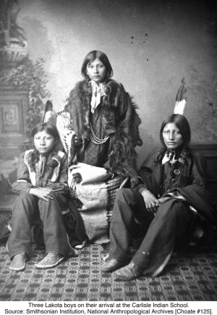As Europeans continued to migrant to North America, however, this peace began to wane, or become weaker. British and French colonists began to fight for control of areas further than the British 13 colonies. They fought with various indigenous communities as allies, but the fighting only grew. Eventually, the British and the French had battles all over the world with the help of other allies like Portugal or Russia. In 1763, the fighting stopped, ending the French and Indian War and the Seven Years War. Britain had gained considerable power in North America. As the war had been very expensive, the British government made colonists pay huge taxes. Colonists were angered by Britain’s actions and this led to the American Revolution.

Following the French and Indian War, King George III declared land west of the Appalachian Mountains land for indigenous communities to live, meaning land east of the mountains was for European settlers. This, however, was only the beginning of the push of indigenous communities further and further from European settlements. This led to a series of wars: the Northwest Indian War (1785-

1795), the War of 1812 (1811-1814), and other wars fought west of the Mississippi River. The Indian Removal Act of 1830 forced indigenous communities to move west of the Mississippi River, but as the law was redefined over time, so were the spaces indigenous communities could live.

*Picture and caption from William Friedheim, Borough of Manhattan Community College, picturinghistory.gc.cuny.edu/two-photos-many-stories/*

* What are some key events of indigenous American history in the US?
* Why do you think life between Europeans and indigenous Americans was less peaceful the more Europeans came?

Appendix C: Native and Indigenous Americans in the United States: Boarding Schools (298)

# Native and Indigenous Americans in the United States: Boarding Schools

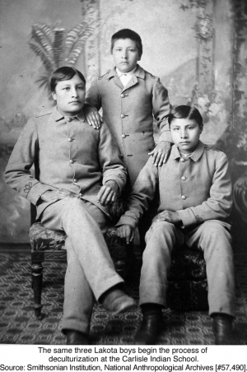Boarding schools for indigenous children slowly began to open around North America. Although there were some boarding schools for indigenous children as early as 1634, more and more began to open in the late 19th century. The goal of these schools were to assimilate3 indigenous children into Euro-American culture and give them an education in Euro-American subjects. Children lived at the boarding schools and were apart from their families. The first schools were opened by missionaries4.

2F

3F

*Picture and caption by William Friedheim, Borough of Manhattan Community College, picturinghistory.gc.cuny.edu/two-photos-many-stories/*

In 1879, Carlisle Indian Industrial School was founded. This boarding school served as a model for other boarding schools across the country. In 1891, the US government issued a law that all indigenous children must attend schools which were designed and administered by the Euro-American population. This law meant federal officers could take children from their home and force them to attend boarding school.

While at these schools, children were forced to change their outward appearance (haircut, clothes, etc.), as well as behavior. Children were not allowed to speak their native languages or practice their spiritual beliefs. Later investigations found that these were schools where children were not treated well and suffered various forms of abuse. After hearing the stories of children who grew up at these schools, the US government

signed the Indian Child Welfare Act into law in 1978, giving Native American parents the legal right to choose where their children were placed in school.

* What do you think life was like for children at the Indian boarding schools?
* Why do you think it took about 90 years for the US government to let indigenous parents choose where their children went to school?

3 The word assimilate has several meanings, but in this context, it means to make a person look like, act, talk, and even think like another person. For example, in order to get indigenous children to assimilate to colonial culture, boarding school staff would cut children’s hair short, make them speak English, and force them to attend a certain church. Had they not been at the boarding school, they might not have done those things themselves.

4 A missionary is a person sent to a place for a religious goal

Appendix D: Native & Indigenous Communities in Siberia: Beginnings to 1917 (425)

**Native & Indigenous Communities in Siberia: Beginnings to 1917**

Like the United States, Russia’s population is incredibly diverse. People practice a variety of religions including Christianity, Islam, and Buddhism. After the United States and Germany, Russia has the largest number of immigrants of any country. More than 120 languages are spoken in Russia, and many of these languages are indigenous languages, or languages of people who are native to the area. In the US, indigenous languages are languages of Native Americans, Hawaiians and Alaskan natives. In Russia there are so many indigenous languages, linguists aren’t sure exactly how many there are. There are too many to count. While there are indigenous people all over Russia, the

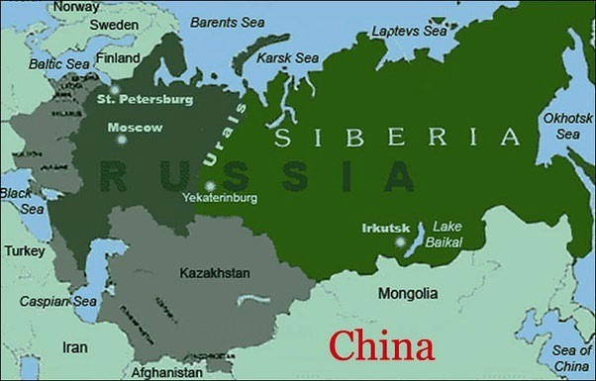

*The bright green part of the map is the part of Russia located in Asia, east of the Ural Mountains. This part of Russia is called Siberia.*

majority of Russia’s indigenous communities live in Siberia, the part of Russia that sits in Asia.

Many indigenous groups in Siberia were nomads, moving around Siberia periodically. In the 13th century, the Mongol Empire conquered part of Siberia, and indigenous communities under Mongolian rule had to pay the Mongols a kind of tax called a tribute. These tributes could be furs, goods, or services. The Mongol Empire stretched all the way to the European part of Russia. By the beginning of the 15th century, the empire began to lose power and other groups claimed their own territory. One of those groups was the Muscovy, which would eventually become the Tsardom of Muscovy, and then the Russian Empire.

In the 16th and 17th centuries, forces from the Tsardom of Muscovy fought other groups which had conquered land from the Mongols in Siberia. The Tsardom wanted land and the people’s tributes. These fights became known as the Russian conquest of Siberia. By 1639, ethnic Russians reached the Pacific Ocean and by 1640, the Tsardom included all of northern Asia, or Siberia. The conquest did not end in 1640, however. While some communities didn’t mind paying tribute to the Tsardom, there were many battles between ethnic Russians and indigenous communities who did not want to pay tribute. Many were killed in battles or by European germs. In some communities, the majority of the community died. The conquest was very difficult for indigenous people.

In the 17th and 18th centuries, the Europeans who lived in Siberia were hunters and those looking for a new life outside of European Russia. Some of those people were Old Believers. Like the Puritans and other first European settlers in North America, the Old Believers lived in Siberia so that they could practice their religion in peace. Even as time passed, there were few Europeans in Siberia, and indigenous communities and European newcomers lived in relative harmony.

* What are some key events in indigenous history of Russia?
* Why do you think the Tsardom of Moscovy wanted to take Siberian land?

Appendix E: Native & Indigenous Communities in Siberia: The Soviet Union and Boarding Schools (307)

**Native & Indigenous Communities in Siberia: The Soviet Union and Boarding Schools**

In 1917, there was a revolution in the Russian Empire. This meant the old government was overthrown and replaced with a new one. The USSR (Union of Soviet Socialist Republics), or the Soviet Union, took its place. The Soviet Union was a country from 1922-1991.

In the early years of the Soviet Union, the government adopted policies designed to preserve indigenous traditions. Schools were opened for indigenous children in their traditional territories and the schedule reflected their seasonal activities. For example, some indigenous groups migrated to a warmer area in the winter. That meant children who were in the area attended school in the warmer months, and in the colder months, the school was closed. The government also created a written standardized version of several languages so that children could learn to read and write in their own language.

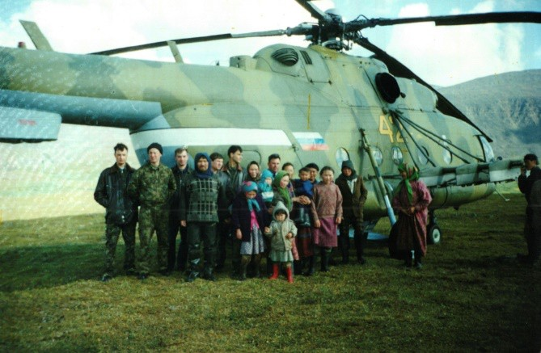

*Nenets (an indigenous group of Siberia) children before they head on the helicopter to school. These children live with their families in the summer and live at a boarding school 9 months of the year. The helicopter takes them to and from school. Photograph by Ikuru Kuwajima , https://flashbak.com/tundra-kids-nenet-children-inside- russias-indigenous-boarding-school-370914/*

When a new leader, Joseph Stalin, came to power, this trend changed. Following World War II, nomadic indigenous groups were forced to settle into one place. From age 2, indigenous children had to attend boarding schools where they could not speak their indigenous language. Students could be taken from their families if their parents refused to send them to boarding school. Students learned Russian language and Russian culture far away from their families and were not able to talk with them during the school year.

By the mid-1980s, children were allowed to return to their home communities thanks to the new openness or *glasnost* policies of the USSR. For the first time, people were able to openly talk about the problems of boarding schools and of children not being able to live with their

families. Smaller schools in settlements and towns began to be built and some nomadic schools returned. Boarding schools remained open, but families could now choose whether or not they wanted to study at them.

* What do you think life was like for children at the indigenous boarding schools?
* Why do you think it took about 40 years for the Soviet government to let indigenous parents choose where their children went to school?

Appendix F: Additional Reading on an indigenous people in Siberia

**“Chukchi always have been and always will be.” How an Indigenous People are Saving their Heritage.**

9 August 2018, 03:28

Article in Russian at: [https://tass.ru/v-strane/5437051,](https://tass.ru/v-strane/5437051) Written by Sergei Sysoikin, photographs by Yuri Smitiuk, translated and adapted by Clare Angeroth Franks

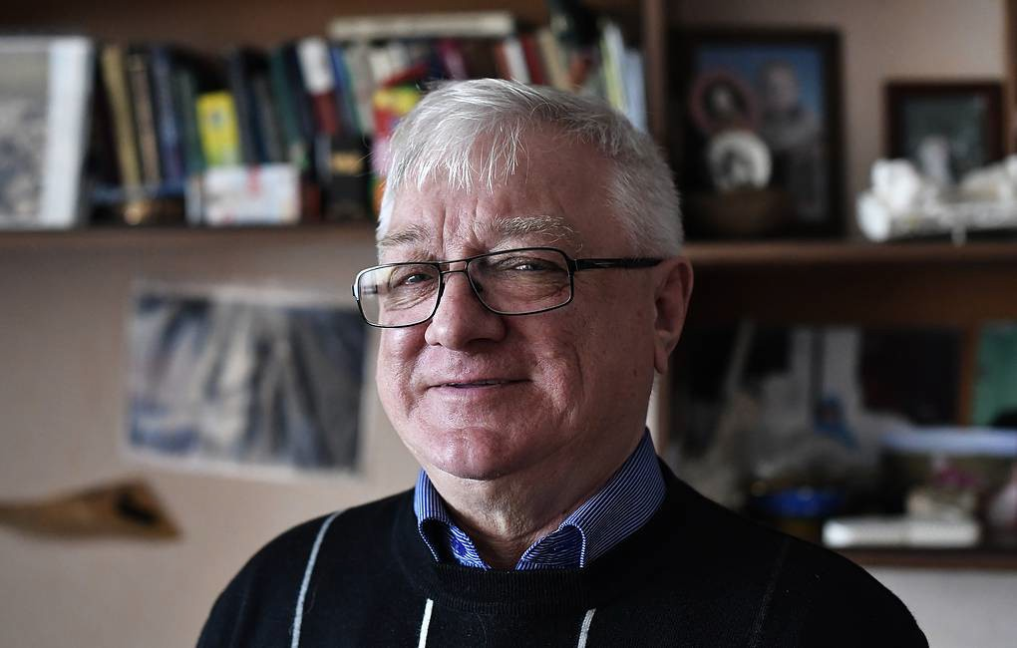

*Mikhail Zelenskii. Photograph by Yuri Smitiuk.*

The world is changing every day. This can be very hard for indigenous people. Indigenous people are the people who lived in a land before settlers came from other places. First Nations or Native Americans are indigenous people in the United States. One of the biggest challenges facing indigenous communities is the loss of language and tradition due to the fast changing world. They feel like they don’t know who they are. They feel that they have lost their identity.

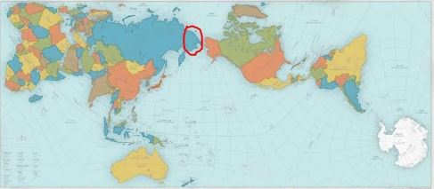

*Chukotka Autonomous Okrug on world map. Map from bigthink.com/design-for-good/award-winning-map-shows-a-more- accurate-world*

# Chukot and Russian

Mikhail Zelenskii is from Chukotka. Chukotka is a Russian peninsula very close to Alaska. About 18,000 Chukchi, an indigenous people, live here. Zelenskii is a native Chukot speaker and has lived in Chukotka his whole life.

Zelenskii lived through one of the most difficult periods in history. During the 1980s and 1990s, life in Chukotka was very hard. People were very poor because of the changes happening to the country. Schools where children learned in their native language had been closed and children learned in *internaty*, or boarding schools.

“Children were torn from their parents, losing their connection to their language. Today in Chukotka, there have been several efforts to bring back and remember the language, but there it’s hard. Chukot is a very complex language and you have to practice it every day,” says Zelenskii.

# A Handbook for Language and Tradition

Thanks to help from the local government and local residents, indigenous language loss in Chukotka is beginning to reverse. Zelenskii is working to create a textbook on Chukot language. Together with the social organization “Chychetkin Vetgav” (or “Native Word”), the team will create video clips for language classes.

“We’ve already planned a topic on *baidars* [a rowing boat for traditional fishing], fishing, reindeer, and dogs. They will all be an important part of the lessons,” says the former official.

The community has also shown an interest in preserving the language through tradition. For example, in the fishing village of Lorino in Chukotka, villagers try to talk about hunting only in Chukot in order to keep the language alive.

“If the Jewish community can bring back their language, why can’t Chukchi do the same?” Zelenskii asked.

# Reconnecting with their Roots

Following a tradition can be important for the survival of a group’s identity. Holidays are traditions. One example of a Chukot holiday is “Erakor,” which is celebrated in the tundra, a region that is so cold, trees cannot grow there. People celebrate with reindeer races where participants not only compete on sleds, but also on their reindeer. There are also food tents and an outdoor market. People wear traditional costumes of fur. If people celebrate these kinds of holidays, they might feel more connected to their identity.

While celebrating traditional holidays can give community members a sense of their Chukot identity, there have also been other projects. The “My Genealogical Tree,” has been very helpful. Communities host competitions where people try to draw an in-depth family tree. A recent competition winner created a family tree which took up 76 pages with information about her relatives and their photographs.

Celebrating holidays and learning about ancestors can strengthen Chukchi identity.

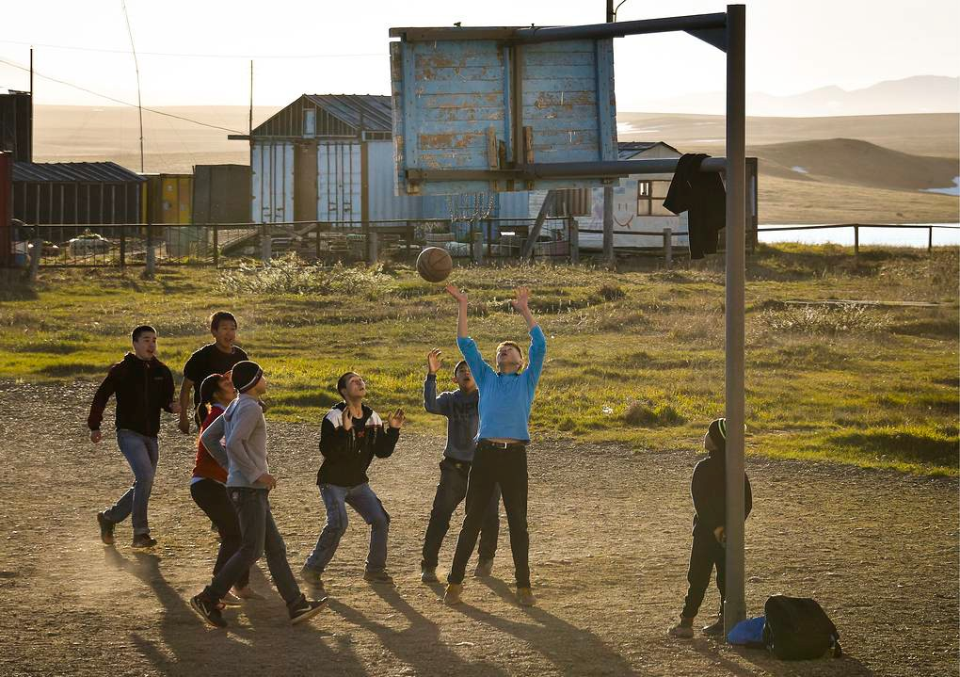

*Children from Lorina village playing basketball.*

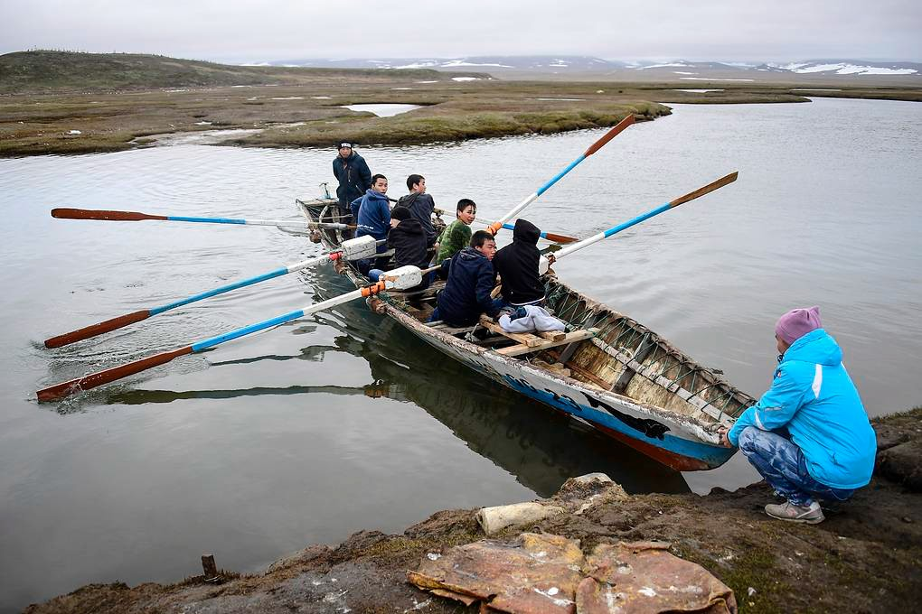

*Youth of Lorino village train on Liugren River before a competition on traditional Chukchi baidars*

# “We Won’t Die Out”

Mikhail Zelenskii is sure that Chukchi have a future.

“Chukchi have always been and always will be,” he states. “I know we can grow. People say where there’s a language, there’s a people. In Alaska, I saw on a sign, ‘We won’t die out,’ and Chukchi won’t die out.”

People from outside of Chukotka are also making sure that Chukchi have a future. For example, outside of Moscow a full-size model of a traditional village was built. People could step inside a traditional Chukot home. There’s even been a book on the Chukchi and a famous linguist is working on a Chukot-French-English dictionary.

“Despite the difficulties of life in the northern region, Chukchi identity and life in Chukotka is definitely thriving.”

Questions on *“Chukchi always have been and always will be.” How an Indigenous People are Saving their Heritage*.

1. Who are Chukchi and where do they live?
2. How has Chukot language loss begun to reverse?
3. Why do you think the Chukot textbook will try to incorporate vocabulary on traditional activities?
4. What are two ways Chukchi are reconnecting with their roots?
5. Do you think it is important to preserve language and culture? Why or why not?

APPENDIX G: Expanding on this Lesson Plan

This lesson plan could easily be part of a larger unit on indigenous peoples, indigenous residential/boarding schools, Indiana history, comparing world regions, or many other units. Below is a list of supplemental materials educators can use to add to the lesson, create a larger unit, or extend the lesson into home assignments.

* + [Tundra Kids,](https://www.amazon.co.uk/d/Books/School-Nenets-Ikuru-Kuwajima/390283384X/ref%3Das_li_ss_tl?ie=UTF8&qid=1484307342&sr=8-3-fkmr0&keywords=nemen%2Bikuru&linkCode=sl1&tag=flashbak04-21&linkId=7828c88cc826c78e32dea7413ff17155) a book of photography by Japanese artist Ikuru Kuwajima. The photographs are of 60 Nenets (an indigenous group of Siberia) children who attend a boarding school 9 months of the year. In the summer, these children live with the families in the Tundra.
  + [Indian Boarding Schools Student Materials,](http://www.loc.gov/teachers/classroommaterials/lessons/indianschools/journal.html) primary sources from the Library of Congress about various people’s attitudes towards Indian Boarding Schools. Educators can also click on the “Teachers” tab underneath the Osage Indian School football team photo for a lesson plan using the primary sources.
  + [Chapter Activities,](https://indianahistory.org/wp-content/uploads/Hoosiers-and-the-American-Story-ch-01.pdf) from Chapter 1: Hoosiers and the American Story by Indiana Historical Society. These activities are found at the end of the chapter.
  + Interestingly, conversations about residential schools in Canada have led to a number of children’s books being published about Canadian native schools. Such books about the indigenous experience in the US have proved harder to find. Students can read about the Canadian experience and compare it to what they’ve learned about the US and Russian contexts. Books for young readers include :
    - [Stolen Words](https://www.amazon.com/Stolen-Words-Melanie-Florence/dp/1772600377/ref%3Dpd_sbs_14_5/132-5870966-7306654?_encoding=UTF8&pd_rd_i=1772600377&pd_rd_r=80cf5288-2036-4a62-817a-93db77082bba&pd_rd_w=MwaHp&pd_rd_wg=Hiqsp&pf_rd_p=52b7592c-2dc9-4ac6-84d4-4bda6360045e&pf_rd_r=52C1DKD05HSC5119SHGS&psc=1&refRID=52C1DKD05HSC5119SHGS) by Melanie Florence (author), Gabrielle Grimard (illustrator)- grade K-3 (there is also a bilingual Cree/English edition)
    - [When We Were Alone](https://www.amazon.com/When-Alone-David-Alexander-Robertson/dp/155379673X/ref%3Dpd_sim_14_1/132-5870966-7306654?_encoding=UTF8&pd_rd_i=155379673X&pd_rd_r=06b1d25f-11c7-4d93-902b-b26e020e3a5f&pd_rd_w=Xb93a&pd_rd_wg=KbSNT&pf_rd_p=5abf8658-0b5f-405c-b880-a6d1b558d4ea&pf_rd_r=RNVS5H5X507V1VBM5VJN&psc=1&refRID=RNVS5H5X507V1VBM5VJN) by David A. Robertson (author), Julie Flett (illustrator)- grade K-3
    - [When I was Eight](https://www.amazon.com/When-Was-Eight-Christy-Jordan-Fenton/dp/1554514908/ref%3Dpd_sbs_14_4/132-5870966-7306654?_encoding=UTF8&pd_rd_i=1554514908&pd_rd_r=982a8250-91c2-413d-a38a-48fca83137a0&pd_rd_w=lIU5r&pd_rd_wg=Lq1lI&pf_rd_p=52b7592c-2dc9-4ac6-84d4-4bda6360045e&pf_rd_r=C5NHY4A6YAFSFWNSHX6Y&psc=1&refRID=C5NHY4A6YAFSFWNSHX6Y) by Christy Jordan-Fenton (author), Margaret Pokiak-Fenton (author), Gabrielle Grimard (illustrator)- grade K-4 (adaptation of Fatty legs)
    - [Shin-chi’s Canoe](https://www.amazon.com/Shin-chis-Canoe-Nicola-I-Campbell/dp/0888998570/ref%3Dpd_sbs_14_1/132-5870966-7306654?_encoding=UTF8&pd_rd_i=0888998570&pd_rd_r=d2fa2512-a3b3-4ca6-969c-8c66ab3db4ea&pd_rd_w=8HZYR&pd_rd_wg=MuE30&pf_rd_p=52b7592c-2dc9-4ac6-84d4-4bda6360045e&pf_rd_r=FCD8SSM4Y61CNS0B9273&psc=1&refRID=FCD8SSM4Y61CNS0B9273) by Nicola I. Campbell (author), Kim LaFave (illustrator)- grade 2-5 (this book is the sequel to Shi-shi-etko)
    - [Shi-shi-etko](https://www.amazon.com/Shi-shi-etko-Nicola-I-Campbell/dp/0888996594/ref%3Dpd_sbs_14_6/132-5870966-7306654?_encoding=UTF8&pd_rd_i=0888996594&pd_rd_r=80cf5288-2036-4a62-817a-93db77082bba&pd_rd_w=MwaHp&pd_rd_wg=Hiqsp&pf_rd_p=52b7592c-2dc9-4ac6-84d4-4bda6360045e&pf_rd_r=52C1DKD05HSC5119SHGS&psc=1&refRID=52C1DKD05HSC5119SHGS) by Nicola I. Campbell (author), Kim LaFave (illustrator)- grade 2-6
    - [A Stranger at Home: A True Story](https://www.amazon.com/Stranger-At-Home-True-Story/dp/1554513618/ref%3Dpd_sim_14_8?_encoding=UTF8&pd_rd_i=1554513618&pd_rd_r=5ac33137-d7ce-4079-9ce2-1dce15a43871&pd_rd_w=ADfqt&pd_rd_wg=dxTPH&pf_rd_p=5abf8658-0b5f-405c-b880-a6d1b558d4ea&pf_rd_r=C7JW37KBCN0QA4MG7KE0&psc=1&refRID=C7JW37KBCN0QA4MG7KE0) by Christy Jordan-Fenton (author), Margaret Pokiak-

Fenton (author), Liz Amini-Homes (illustrator)- grade 3-7

* + - [I Am Not a Number](https://www.amazon.com/Not-Number-Jenny-Kay-Dupuis/dp/1927583942/ref%3Dpd_sbs_14_6/132-5870966-7306654?_encoding=UTF8&pd_rd_i=1927583942&pd_rd_r=6f301c17-f050-43bb-a508-7f37cddf5a6c&pd_rd_w=SnXNH&pd_rd_wg=sa5DV&pf_rd_p=52b7592c-2dc9-4ac6-84d4-4bda6360045e&pf_rd_r=KXWKNC4HZ5WCJX7FZ2G8&psc=1&refRID=KXWKNC4HZ5WCJX7FZ2G8) by Jenny Kay Dupuis (author), Kathy Kacer (author), Gillian Newland (illustrator)- grade 4-6
    - [Speaking Our Truth: A Journey of Reconciliation](https://www.amazon.com/Speaking-Our-Truth-Journey-Reconciliation/dp/1459815831/ref%3Dpd_sim_14_2/140-9591590-2744963?_encoding=UTF8&pd_rd_i=1459815831&pd_rd_r=5ac33137-d7ce-4079-9ce2-1dce15a43871&pd_rd_w=ADfqt&pd_rd_wg=dxTPH&pf_rd_p=5abf8658-0b5f-405c-b880-a6d1b558d4ea&pf_rd_r=C7JW37KBCN0QA4MG7KE0&psc=1&refRID=C7JW37KBCN0QA4MG7KE0) by Monique Gray Smith- grade 4-7
    - [Fatty Legs](https://www.amazon.com/Fatty-Legs-Christy-Jordan-Fenton/dp/1554512468) by Christy Jordan-Fenton (author), Margaret Pokiak-Fenton (author), Liz Amini-Holmes (illustrator)- grade 4-8
    - [My Name Is Seepeetza](https://www.amazon.com/My-Name-Seepeetza-Shirley-Sterling/dp/0888991657/ref%3Dpd_sim_14_6/140-9591590-2744963?_encoding=UTF8&pd_rd_i=0888991657&pd_rd_r=5ac33137-d7ce-4079-9ce2-1dce15a43871&pd_rd_w=ADfqt&pd_rd_wg=dxTPH&pf_rd_p=5abf8658-0b5f-405c-b880-a6d1b558d4ea&pf_rd_r=C7JW37KBCN0QA4MG7KE0&psc=1&refRID=C7JW37KBCN0QA4MG7KE0) by Shirley Sterling- grade 5-7
    - [An Indigenous Peoples' History of the United States for Young People (ReVisioning](https://www.amazon.com/Indigenous-Peoples-History-ReVisioning-American/dp/0807049395/ref%3Dpd_bxgy_14_2/140-9591590-2744963?_encoding=UTF8&pd_rd_i=0807049395&pd_rd_r=677b1657-7a66-4d2f-8ce7-770d5db82a95&pd_rd_w=Yn2tv&pd_rd_wg=OoXx7&pf_rd_p=09627863-9889-4290-b90a-5e9f86682449&pf_rd_r=E4V5B5CXSMGQ9N7WK9MH&psc=1&refRID=E4V5B5CXSMGQ9N7WK9MH) [American History for Young People)](https://www.amazon.com/Indigenous-Peoples-History-ReVisioning-American/dp/0807049395/ref%3Dpd_bxgy_14_2/140-9591590-2744963?_encoding=UTF8&pd_rd_i=0807049395&pd_rd_r=677b1657-7a66-4d2f-8ce7-770d5db82a95&pd_rd_w=Yn2tv&pd_rd_wg=OoXx7&pf_rd_p=09627863-9889-4290-b90a-5e9f86682449&pf_rd_r=E4V5B5CXSMGQ9N7WK9MH&psc=1&refRID=E4V5B5CXSMGQ9N7WK9MH) by Jean Mendoza, Debbie Reese, Rozanne Dunbar-

Ortiz- grade 7-9

* + - [Secret Path](https://www.amazon.com/Secret-Path-Gord-Downie/dp/1501155946/ref%3Dpd_sim_14_10?_encoding=UTF8&pd_rd_i=1501155946&pd_rd_r=5ac33137-d7ce-4079-9ce2-1dce15a43871&pd_rd_w=ADfqt&pd_rd_wg=dxTPH&pf_rd_p=5abf8658-0b5f-405c-b880-a6d1b558d4ea&pf_rd_r=C7JW37KBCN0QA4MG7KE0&psc=1&refRID=C7JW37KBCN0QA4MG7KE0) by Gord Downie (author), Jeff Lemire (illustrator)- grade 7-12 (The book is a ten song digital album with a graphic novel)
    - [Turtle Island: The Story of North America's First People](https://www.amazon.com/Turtle-Island-Story-Americas-People/dp/1554519438/ref%3Dpd_sim_14_1/140-9591590-2744963?_encoding=UTF8&pd_rd_i=1554519438&pd_rd_r=5ac33137-d7ce-4079-9ce2-1dce15a43871&pd_rd_w=ADfqt&pd_rd_wg=dxTPH&pf_rd_p=5abf8658-0b5f-405c-b880-a6d1b558d4ea&pf_rd_r=C7JW37KBCN0QA4MG7KE0&psc=1&refRID=C7JW37KBCN0QA4MG7KE0) by Yellowhorn and Lowinger- grade 7-12