## Exploring Russian & East European Architecture through Shapes: A Unit for Kindergarteners

This unit was created for kindergarteners at Clear Creek and Marlin Elementary Schools in Bloomington, Indiana. The goal of the unit is to introduce students to Russia and East Europe, using two-dimensional geometric shapes. This unit consists of three lessons and can be used in art or math classrooms as the unit addresses Indiana Academic Standards in both math and visual art. This unit offers extensions for each lesson, giving educators flexibility in which activities they wish to employ in the classroom. Educators may adopt the activities or appendices for use in a lesson plan of their own or they may use the unit plan in full.

Educators may also contact Indiana University’s Russian and East European Institute (REEI) to arrange for faculty, advanced graduate students, or international students to give a presentation on architecture in Russia and Eastern Europe, art in the region, or another related topic. Please contact Mark Trotter for further information about the Russian and East European Institute or any of its outreach programs at [martrott@indiana.edu](mailto:martrott@indiana.edu).

**Objectives:** By the end of this unit, students should be able to:

* recognize and name five two-dimensional shapes (triangle, circle, semicircle, square, and rectangle)
* identify these shapes in the world around them
* detect shape similarities and differences
* understand that all objects are made of shapes
* locate the shapes in relation to other objects using location prepositions
* recognize onion domes as a feature in Russian architectural style

**Indiana State Standards and Indicators Addressed:**

* Math Standards:
  + PS.7: Look for and make use of structure
  + K.CA.5: Create, extend, and give an appropriate rule for simple repeating and growing patterns with numbers and shapes
  + K.G.1: Describe the positions of objects and geometric shapes in space using the terms inside, outside, between, above, below, near, far, under, over, up, down, behind, in front of, next to, to the left of and to the right of.
  + K.G.2.: Compare two- and three- dimensional shapes in different sizes and orientations, using informal language to describe their similarities, differences,

parts (e.g. number of sides and vertices/”corners”) and other attributes (e.g., having sides of equal length).

* + K.G.3: Model shapes in the world by composing shapes from objects and drawing shapes.
  + K.G.4: Compose simple geometric shapes to form larger shapes.
* Visual Art Standards:
  + K.1.3. Identify simple images and subject matter in works of art
  + K.6.1: Use objects or animals from the real world as subject matter for artwork
  + K.6.4: Demonstrate thoughtfulness and care in creating artwork
  + K.7.1: Begin to recognize and use elements (such as line, shape, texture, and color) and principles (such as repetition) in artwork
  + K.7.2: Discriminate between types of lines, shapes, textures, and colors in own work and the work of others.

### Lesson 1: Geometric Shapes

This unit was adapted from <http://www.k5architecture.org/pdf/g0%20-%20Kindergarten.pdf> and expanded upon. Sources for pictures used in lesson 1 include: Pixabay, Microsoft Office, Clear Creek Elementary School homepage, and Google Maps Street View.

**Overview:** Students will be introduced to the following shapes: circle, semicircle, rectangle, square, and triangle. Students will identify similarities and differences in shapes. Students will cut out shapes from a handout. Students will then trace those shapes on pictures of various buildings.

**Supplies Needed:** Scissors, markers or crayons, handout of shapes (see appendix A), handout for cutout shapes (see appendix B), handout of building examples (see appendix C, but can create own with examples familiar to students), and tracing paper (optional). For large classes or shorter class times, educators might want to have pre-cut shapes for their students to use.

*Extension materials*: Picture book *Color Zoo* by Lois Ehlert, post-its/sticky notes with each note having one of the five shapes already written on them.

**Pre-requisite Knowledge:** Students should know how to hold markers or pencils independently. Students should know what a line is and how to make one. Students should know what a building is.

**Vocabulary:** Shape, trace, circle, semicircle, rectangle, square, triangle

**Warm Up:** Review lines with students. Reinforce that lines can be thick or thin, curved or straight, and multicolor. Students may draw lines to fortify their knowledge.

**Introduce Topic:** On a projector, screen, or with a printout of appendix A, show the class the five shapes. Tell students that these are examples of shapes. Shapes are objects made out of lines. Sometimes these lines are straight. Sometimes these lines are curved. Shapes help make up objects that we use, play, and work with every day. Shapes can be large or small. Shapes can be one color, many colors, or clear. Bring students’ attention to the handout/screen/etc. Tell students that these are 5 shapes that we see regularly. Repeat the names of the shapes and ask students to tell you the names of the shapes, changing up the order until you feel all students can name the shapes.

*Extension*: Read *Color Zoo* by Lois Ehlert to the class. Be sure to identify the spine, cover, title, and other parts of the book. Ask students what shapes they see on certain pages and use sticky notes to label the shapes. If students have learned primary and secondary colors, ask them to identify which shapes have primary colors and which have secondary colors.

**Activity:** If cutting, have students cut out the shapes from appendix B. When everyone has the shapes cut out, you can quiz the students by having them lift the shape you call out. Ask

students what makes each of these shapes different from one another. Explain that various shapes have various numbers of sides and corners (vertices).

Shapes can be many sizes, and sides of shapes can be varying lengths. What is most important is the number of sides a shape has. If possible, show them various sizes of rectangles, triangles, etc. Quiz the students by having them lift the shape with, for example, three sides. Continue to quiz the students until you feel they generally understand this concept. Be sure to emphasize the difference between squares and rectangles.

*Extension:* Give students sticky notes with the names of shapes on them. Invite students to put their sticky note on a corresponding shape in the room. After enough time has passed, go over some of the shapes together, reminding students that the number of sides determines what the shape is.

Draw their attention back to the screen/projection/etc., where you have a photo of a building. Remind the students that our world is made of shapes. Demonstrate this to them by tracing a shape onto the building that matches the shape seen. Explain that you are *tracing*. To trace is to create an outline of a shape *on top of* the original shape. When we trace a shape, we do not color it in. Next, hand out pictures of various buildings (appendix C, or your own) and tracing paper, if desired. Have students trace shapes onto the buildings, or simply trace over the shapes they see on the buildings on tracing paper.

**Wrap-up:** Once again, tell students that shapes are made out of lines. Show the students each of the five shapes and remind them that the number of sides determines what shape they are.

**Modification for advanced/less advanced students**: Give more advanced students more complicated buildings to trace and less advanced students more simple buildings to trace. Some advanced students may trace freely without the help of cutouts. Less advanced students may need to be reminded what shape they are tracing and why it is that shape.

### Lesson 2: Shapes and Location Vocabulary

Sources for pictures used in lesson 2 include: 7esl.com and Microsoft Office.

**Overview:** Students will review the following shapes: circle, semicircle, rectangle, square, and triangle. Students will be reminded of similarities and differences in shapes. Students will create pictures of objects using shapes by using the terms inside, outside, between, above, below, near, far, under, over, up, down, behind, in front of, next to, to the left of and to the right of.

*Note:* Activity 1 in this lesson should be modified for students who have difficulty quickly moving around a space. If no modification can be made, Activity 2 and the extension can be used instead.

**Supplies Needed:** Location preposition vocabulary pictures (appendix E and F). For Activity 1, a large square on the floor, large enough for all of the students to stand inside. This can be created by drawing an outline with masking tape on your classroom floor, using chalk on the blacktop outside, using the lane lines of a basketball court, or you can use desks to create a rectangle in your classroom. For Activity 2, crayons and a printout of a square (appendix G). For the extension, cutouts of shapes (appendix D. You can either cut them out on construction paper or you can have students cut them out as part of your class time), glue, paper, and copies of shape images (appendix H).

**Pre-requisite Knowledge:** Students should know that shapes are made out of lines. Students can recognize and name circle, semicircle, rectangle, square, and triangle shapes. Students understand that the number of sides and corners determines the name of the shape.

**Vocabulary:** inside, outside, between, above, below, near, far, under, over, up, down, behind, in front of, next to, to the left of, to the right of

**Warm Up:** Using the images from lesson one, show/project one of the five shapes to the students. Have them name the shape and say why it is that shape. Go through each of the five shapes. Show the students a building and ask them what shapes they see. Trace the shapes onto the image.

**Introduce Topic:** After tracing the shapes onto the image, tell students that there are words we use to describe where things are in relation to other things. Using the lesson’s vocabulary and the shapes just traced, describe each of the shapes’ location. Then, using the location preposition vocabulary pictures (appendix E), go through each of the location vocabulary words. Remind students that these words are used when they are describing a shape’s location in relation to another shape. Use appendix F to quiz students or to solidify the information. *See optional modification below.*

**Activity 1:** Take students to the proper location for this activity (see supplies needed). If the activity takes place in the classroom, move the desks accordingly. There should be some sort of rectangle in the center of the room or area. Tell students to imagine they are a shape. It does

not matter what shape they are. They are to move in relation to the rectangle on the floor. Choose which direction is “up” and which direction is “right.” Remind students that their left hand makes an L. You, the teacher, will announce one of the location words. All students must then move to that location. If you like, you can have the last student to reach the correct location sit down until one student is left standing. You can also time how quickly all students can reach the correct location. Another variation is to assign students a shape and have them tape a picture of that shape to themselves. The teacher can choose all shapes or only certain shapes to move to a certain location.

*Variation:* Play Simon Says using the lesson’s vocabulary. Have students move in relation to the rectangle on the ground.

**Activity 2:** Hand out appendix G and crayons. Make sure all students have access to the same colors. Tell students to draw a certain colored shape in a location in relation to the square. In order to keep track, also draw those colored shapes on your own paper. When you have gone through all of the vocabulary, go through what you called out on the screen/projection so that students can see whether or not they accurately drew the shapes and the locations.

*Extension*: This extension should be modeled by two adults using the screen/projector/etc. Hand out cutouts of shapes (or have students cut out the shapes), glue, and paper or pass out paper and crayons or markers. When the shapes are cut out or all materials are distributed, explain to students that they will be working in partners to create a picture. Tell them that they will be given a secret image. Give the volunteer modeling with you one of the pictures from appendix H. Tell the students that the volunteer will be telling you what shape goes where on your paper. You don’t know what you will be creating. The volunteer will tell you to start with a shape. You will put the cut out of that shape (or draw it) in the middle of the screen/projection. The volunteer will use the vocabulary from the lesson to describe the image to you, telling you where to put other shapes. The volunteer will tell you when the object is finished.

Give each student a copy of one of the objects from appendix H. Remind students that these pictures are for their eyes only. Pair students by assigning students numbers 1 or 2, or use your own system to pair students. 1 students will describe their object to 2 students first. 2 students will glue the objects onto their paper (or draw the shape onto their paper). When 1 student is finished describing, they will compare the drawing to the handout. Does it look the same? Then 2 student will describe their object to 1 student. If students finish early, you may give them other objects to describe and create.

**Wrap-up:** Have students clean their spaces and then have their attention on the board/screen. Review the location vocabulary using appendix F.

**Modification for advanced/less advanced students:** For less advanced students, spend more time on the topic introduction and provide them with fewer vocabulary words. The prepositions listed in the lesson come from the Indiana Academic Standards, but educators may

choose to use different vocabulary which best fits their needs. For extension modification, give more complicated objects from appendix H to more advanced students and simpler objects to less advanced students.

### Lesson 3: Shapes in East European & Russian Architecture: Onion Domes

Sources for pictures used in lesson 3 include: Microsoft Office, Pixabay, and Google Maps and Google Search.

**Overview:** Students will review the following shapes: circle, semicircle, rectangle, square, and triangle. Students will be reminded of similarities and differences in shapes as well as location prepositions. Then, students will learn about architectural styles, especially onion domes.

Students will go on a virtual tour of famous sites with onion domes in Russia, Ukraine and Estonia. Students will then create their own onion dome buildings using shape cutouts.

**Supplies Needed:** The ability to project/show appendix A, appendix F, appendix I and Google Maps/Images from Google. Cutouts of shapes (may use leftovers from lesson 2 extension activity or appendix J) from various colored construction paper, paper, and glue. An example of the architect activity can be found in appendix K or educators may create their own example.

*Extension materials*: Metallic paint or gel pens, postcards (appendix L).

**Pre-requisite Knowledge:** Students should know the following shapes: circle, semicircle, rectangle, square, and triangle. Students should know what sides and corners (vertices) are and why they are important. Students should know the location preposition vocabulary from lesson

2. Students should know generally where their school is located.

**Vocabulary**: architect, architectural style, feature, onion dome

**Warm Up:** Begin the lesson by reviewing the five shapes and the location preposition vocabulary from lessons 1 & 2 with the help of appendix A and F. Students can review terms from both lessons by the teacher telling all students to place various shapes in various locations on the students’ desks. You or a volunteer can walk around the room to ensure students are using the correct shapes and putting them in the correct places.

**Introduce Topic**: Invite your students to sit closer or face the screen/projection. Through the use of Google Maps or on a large map printout, show your students where your school is located. Slowly zoom out, showing them your city, state, and country. Tell your students that buildings in the United States look different from buildings in other countries. The style of what a building looks like is called architectural style. Architects are people who design buildings.

Today, your students will be architects, using shapes and a feature of the Russian architectural style to create a picture of a building.

**Exploration Map Activity and Learning about Onion Domes**: Using Google Maps, tell the students that together you will visit Eastern Europe and Russia to gather ideas for the building they will design. Your first destination will be Moscow, Russia. Search on Google Maps for *St. Basil's Cathedral, Red Square, Moscow, Russia*. Tell students that a distinct feature of Russian architecture is the onion dome found on top of Orthodox churches in Russia and Eastern Europe. Features are specific things that help us recognize what something is or where something belongs. For example, a feature of a school is that there are students and teachers

who regularly go to the building. A feature of an apple is that it is round, and it has a sweet, juicy taste. A traditional feature of a Russian architecture is an onion dome. Tell students that they are looking at St. Basil’s Cathedral. The cathedral used to be a church, but now it is a museum. Ask students why they think the colorful domes on top of the building are called onion domes. If they know what an onion looks like, they will probably tell you they look like onions. If students do not know what an onion looks like, you might want to show them a picture of an onion to give them context.

If you can, change your screen to show appendix I. Read the information on the appendix to your students. If you would like to save time, you may simply summarize the information found there. If you like, you can mention that the average height of a 5-year-old is 43 inches when you get to the section about average snowfall. You can also explain what a museum is and why it’s important to have museums of art, history, etc.

From here, you will have the option to click through pictures of the site or use street view to explore St. Basil’s Cathedral. If technology is limited, you may choose to show pictures of St. Basil’s Cathedral which you have previously downloaded to show the class. Be sure to ask students what they see using vocabulary from lesson 2. When you feel enough time has passed, feel free to “visit” other sites with the students as time allows. Other famous East European buildings with onion domes you can bring up on Google Maps are:

* Cathedral of Christ the Saviour, Moscow, Russia
* Savior on the Spilled Blood, Griboyedov channel embankment, Saint Petersburg, Russia
* Ipatiev Monastery, Kostroma, Russia
* St. Michael's Golden-Domed Monastery, Kyiv, Ukraine
* Alexander Nevsky Cathedral, Lossi plats, Tallinn, Estonia

**Architect Activity**: Now that your students have seen several examples of onion domes, tell them that they will use shapes to design their own buildings with onion domes! Show them an example you have created by cutting out shapes from various colors of construction paper. You may also use appendix K, although it is not made with construction paper. The shapes students use can be cut from appendix J, or students can use previously cut shapes from other lessons. Students will glue shapes onto paper to create their own onion dome building.

*Extension*: Students can add details with metallic paint or gel pens to their buildings.

Wrap-up: Show the class your example building and ask the class what shapes they see, what shapes they don’t see, and what shapes they used on their own dome. Ask them why they chose certain colors and remind them that different dome colors have different meanings on churches in Russia and Eastern Europe. Ask them why they decided to put certain shapes on top of, next to, etc. other shapes or ask them to tell you what color an object is using the lesson 2 vocabulary on your example.

*Wrap-up extension*: Handout postcards (appendix L) to students with their names in Russian/Cyrillic using Google Translate. These postcards will go home with the students. Tell students that in Russia, people speak a language called Russian, which uses a different alphabet. If you like, a volunteer from REEI can come to your classroom to write students’ names on their postcard and assist in your classroom during the lesson. You can coordinate volunteers by emailing REEI Assistant Director and Outreach Coordinator Mark Trotter at [martrott@indiana.edu](mailto:martrott@indiana.edu).

### Appendices for Kindergarten REE Architecture Shapes Unit

Appendix A: Shapes to show (lesson 1)

## Circle Square Triangle

**Rectangle Semicircle**

Appendix B & D: Shapes for tracing (lesson 1) and for cutouts (lesson 2)



Appendix C: Buildings to trace (lesson 1)

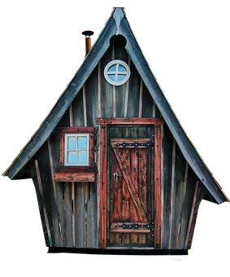

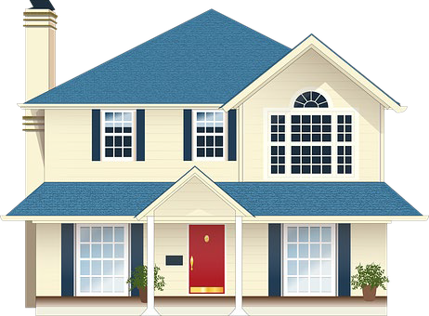

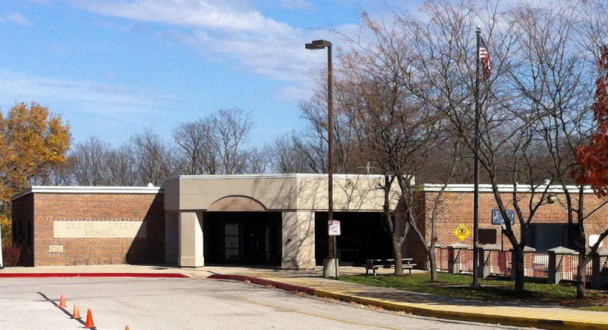



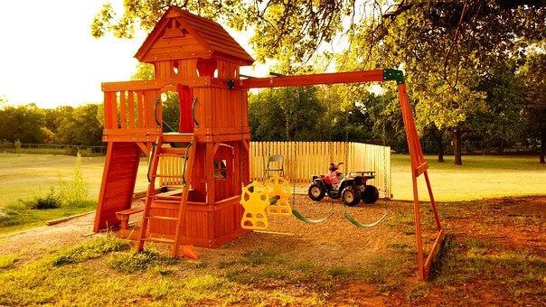

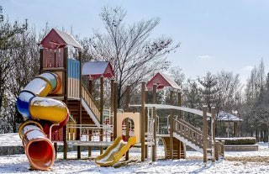

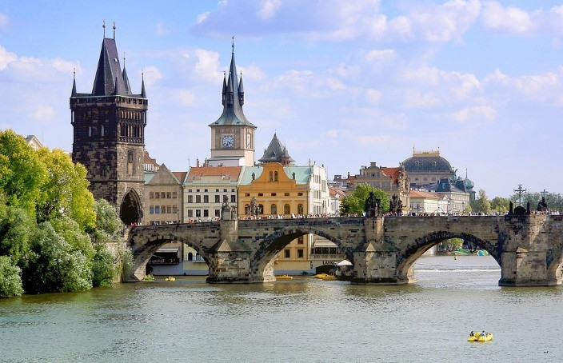

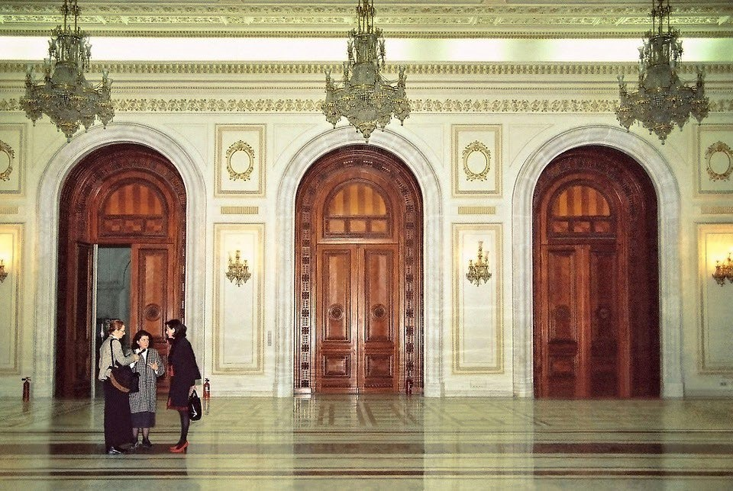



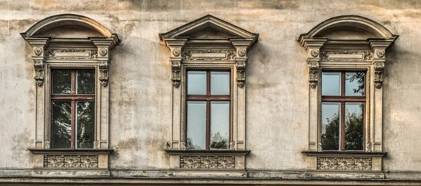

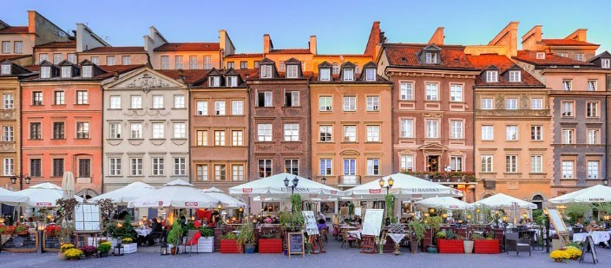

Appendix E: Location preposition pictures (the ball in relation to the box; lesson 2)



Near



Far



To the Left of

To the Right of

Under

Over

Below & Down

Above & Up

Between

Next to



Inside

Outside

In front of

Behind

Appendix F: Location preposition pictures without label (the ball in relation to the box; lesson 2)









Appendix G: Square activity (lesson 2)

Appendix H: Shape images (lesson 2, extension) House and Tree:

Butterfly:

Rocket:

Boat:

Flower:

Appendix I: Reading on onion domes (lesson 3)

## Onion Domes: A Feature of Russian Architecture

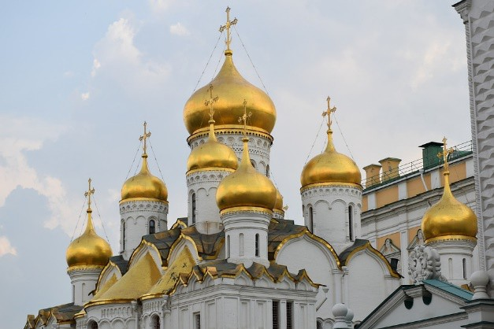While onion domes can be found on buildings all over the world, they are a typical feature of Russian architecture and are usually found on Russian Orthodox churches. Onion domes are domes whose shape looks like an onion. People believe Russians began to use onion domes on churches as early as the thirteenth century. That’s 800 years ago!

This church has many golden onion domes. How many do you see?

Russia is the largest country in the world.

Moscow, the capital of Russia, gets about 60 inches of snow each year. Indianapolis, the

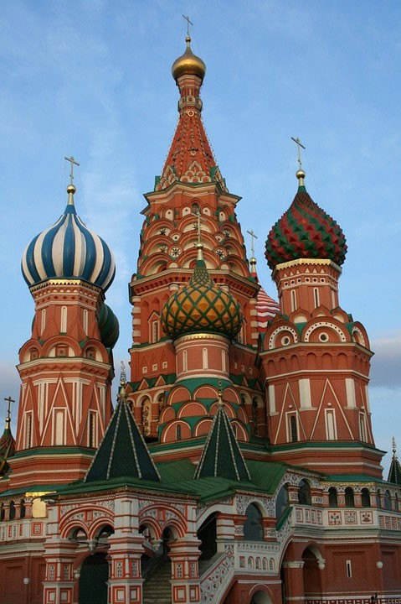capital of Indiana, only gets about 22 inches of snow each year. It is said that Russian architects designed buildings with onion domes, because snow can easily slide off of the dome. However, other people say that onion domes are designed to look like the flame of a candle. Traditionally, people light candles when they enter a Russian Orthodox church to pray.

Color is important on onion domes. Different colors mean different things. Churches with green or silver onion domes honor saints, or people thought to be especially close to their god. Monasteries or convents often have black onion domes. Monks and nuns live in monasteries and convents. They are people who devote their life to their religion. Onion domes aren’t always on churches, however. St. Basil’s Cathedral, an important symbol of Russia, has been a museum since 1928. Each of the domes on St. Basil’s Cathedral has different colors and has a different pattern. The building is more than 400 years old and was built to look like a flame, rising to the sky.

St. Basil’s Cathedral is on Red Square in Moscow, Russia. Each onion dome is different.

Appendix J: Cutout shapes for dome activity (lesson 3)

Appendix K: Example of architecture activity (lesson 3)

Appendix L: Postcards (lesson 3 extension)

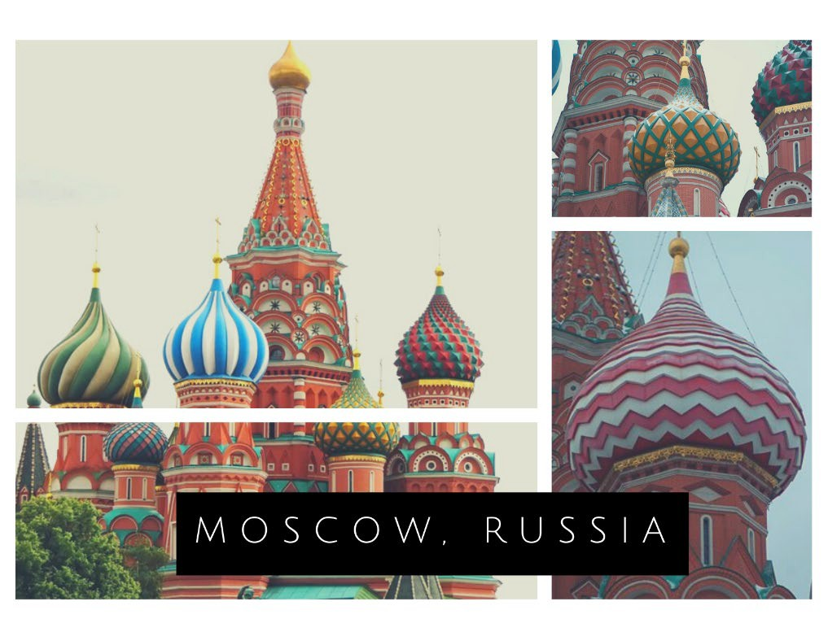

A

Appendix L: Postcards (lesson 3 extension)

ST BASIL'S CATHEDRALI

MOSCOW, RUSSIA

# Hello from Moscow, Russia! Today I learned about onion domes and shapes in Russian and East European architecture. Ialso created my own building with onion domes using triangles, semicircles, and rectangles!

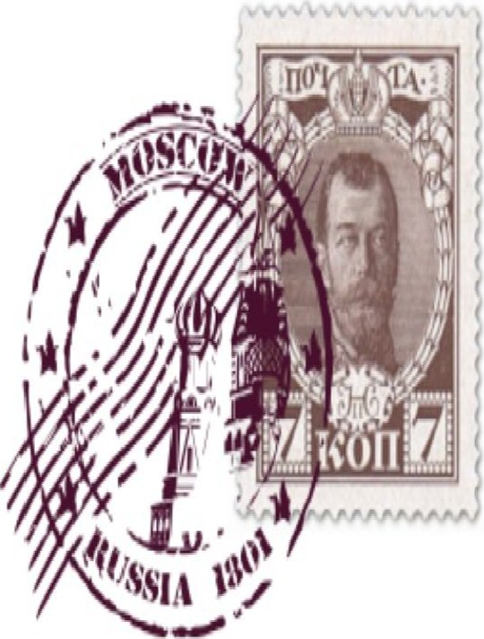

# From:

ST BASIL'S CATHEDRALI

MOSCOW, RUSSIA

Hello from Moscow, Russia! Today I learned about onion domes and shapes in Russian and East European architecture. Ialso created my own building with onion domes using triangles, semicircles, and rectangles!

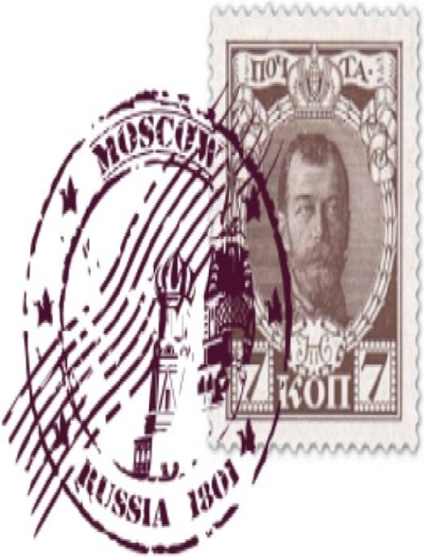

From:

**HAMILTON LUGAR**

W

**SCHOOL OFGLOBAL ANDINTERNATIONAL STUDIES**

**RussianandEastEuropeanlnstitute**

**HAMILTON LUGAR**

SCHOOLOFGLOBAL ANDINTERNATIONIJ.STUDIES

W

Russ1anandEastEuropeanlnslitute

Appendix L: Postcards (lesson 3 extension)

33